WKLogo_CMYK.eps

CCH OneClick

Guide for Clients



Legal Notice

Disclaimer

Wolters Kluwer (UK) Limited has made every effort to ensure the accuracy and completeness of this Quick Start Guide. However, Wolters Kluwer (UK) Limited, its staff and agents will not be liable for any errors or omissions and use of the software is subject to the customer’s licence with Wolters Kluwer (UK) Limited. This Quick Start Guide should not be relied upon as a detailed specification of the system or the software.

Wolters Kluwer (UK) Limited may make changes to this Quick Start Guide from time to time.

Copyright

This Quick Start Guide may not be copied, altered, edited, disposed of or distributed without the prior consent of Wolters Kluwer (UK) Limited. The content is confidential.

Unless indicated otherwise all elements of this software product are owned by Wolters Kluwer (UK) Ltd.

© 2015 Wolters Kluwer (UK) Limited

Trademark Rights

Microsoft, Windows, Windows NT, Windows for Workgroups, Windows 98, 2000, XP, MS-DOS, Windows Vista, Windows 7, Windows 8, Windows 10, Windows Server, Microsoft SQL Server, and Microsoft Office, are either registered trademarks or trademarks of Microsoft Corporation. Novell and NetWare are trademarks of Novell Inc. Citrix MetaFrame is a registered trademark or trademarks of Citrix Systems, Inc. All rights reserved.

All other trademarks are the property of their respective owners.

Wolters Kluwer (UK) Limited  
145 London Road,   
Kingston Upon Thames,   
Surrey   
KT2 6SR

Contents

[1. CCH OneClick Activation 1](#_Toc48645082)

[2. Messages & Documents 1](#_Toc48645083)

[2.1 Messages 2](#_Toc48645084)

[2.2 Documents 4](#_Toc48645085)

[3. Digital Data Request 7](#_Toc48645086)

[4. VAT Returns 10](#_Toc48645087)

# CCH OneClick Activation

To enable you to use both the Messages & Documents and the Digital Data Request App functionality within CCH OneClick, you will need to have an activated CCH OneClick account

If you haven’t already activated your workspace, you should have received an activation email sent by your accountant from [notifications@accountantspace.co.uk](mailto:notifications@accountantspace.co.uk)

* Click the link in the email and use your email address to log in
* Enter your activation ID (Your practice will have informed you of this, or you will have received a text message when your account was activated)
* Create a password
* Select 2 security questions
* Log into the client workspace using your email address and new password

Your workspace will show the **Messages & Documents**, **Digital Data Request** and/or the **VAT Returns** tiles depending on the access given to you by your practice

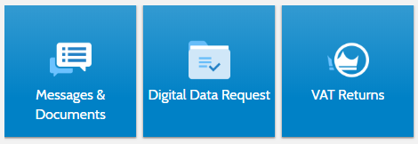

# Messages & Documents

* Messages & Documents is the functionality within CCH OneClick that allows you to exchange messages, files and information online (previously known as Client Portal)
* It is accessed through your client workspace within CCH OneClick

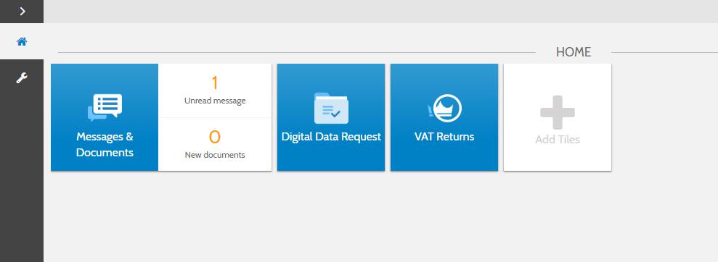

* From the home page you can see a summary of each account you have access to
* If you are an associated contact of multiple businesses you will be able to see them all here

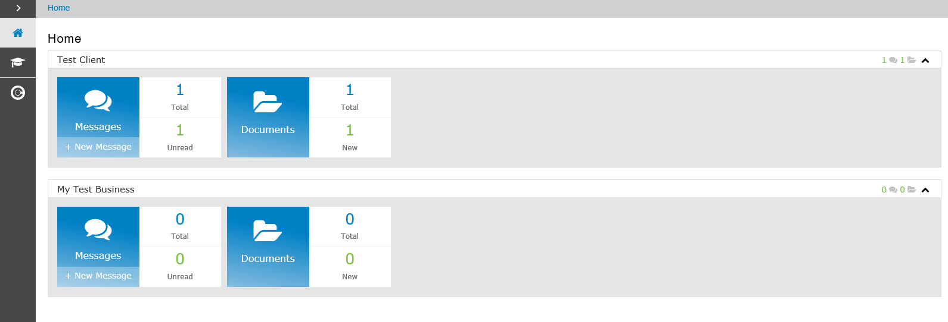

## Messages

* The Messages tile will take you to the conversations for that account
* There is also an indicator here of how many messages you have and how many are unread
* You will be sent an email notification when you receive a new message

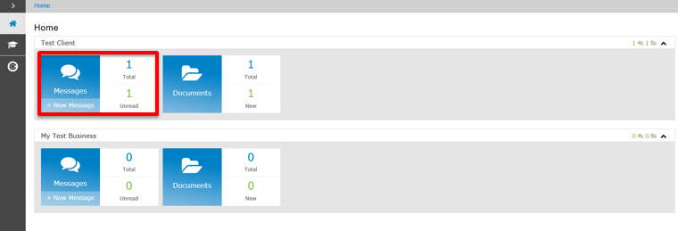

* Select the + button to create and send a new message

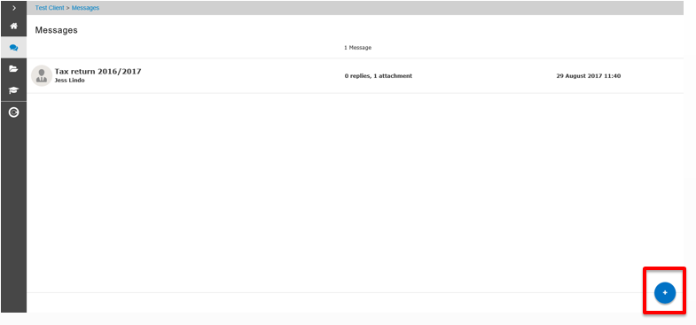

* The exclamation mark signals that there is a document within this conversation needing your approval

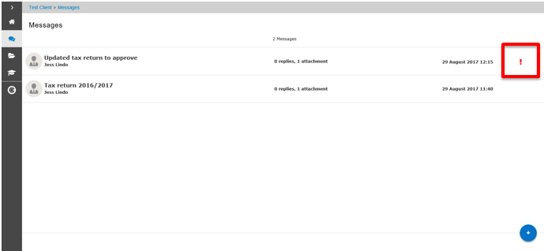

* Select here which option you’d like to choose

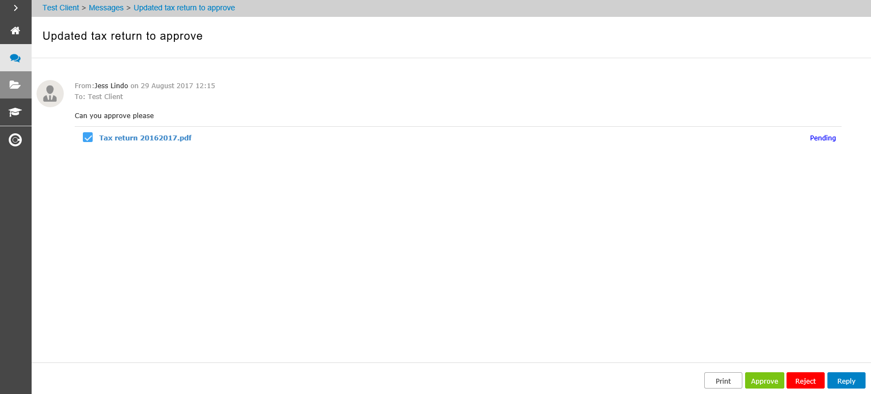

* If approving the document, enter your login password
* You may have to view the document first before it can be approved

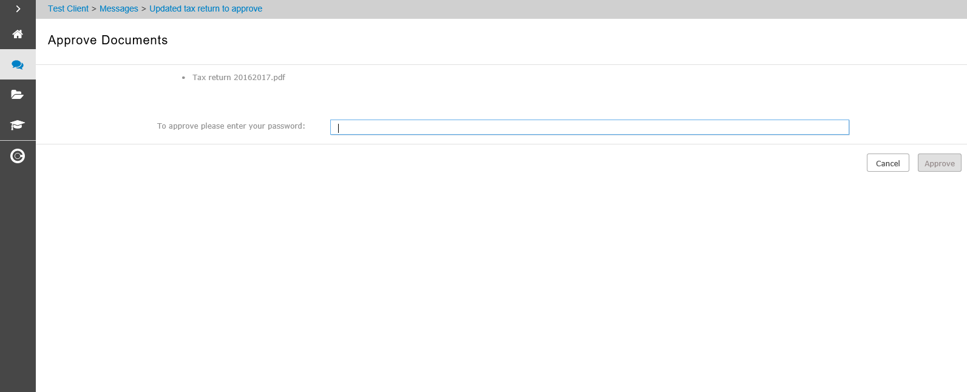

* Use the home button to return to your list of available accounts

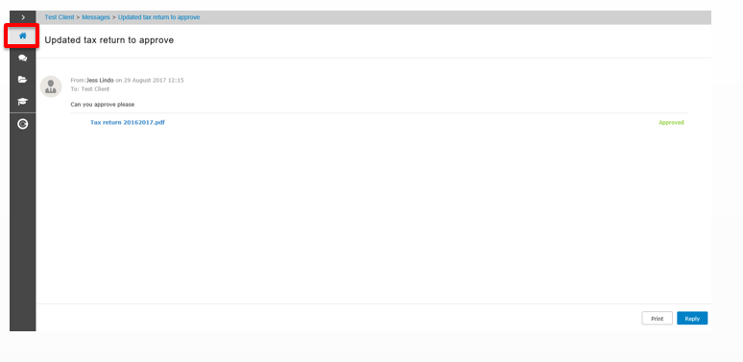

### Adding multiple employees to a message

* Multiple CCH OneClick activated employees who are in your client team can be copied in when creating or replying to a message. Additional employees will appear in the **To** field

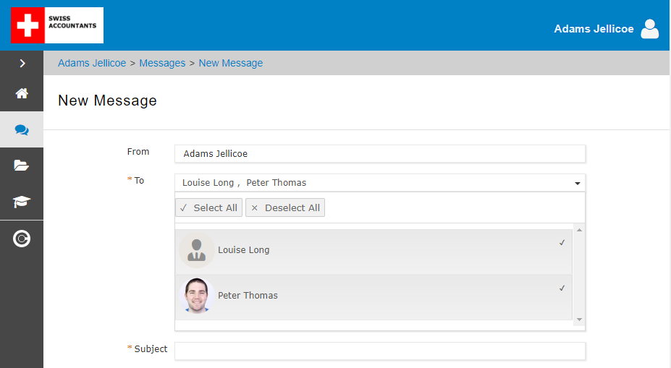

## Documents

* The documents tile will take you to all the documents available for that particular account
* Select the new folder to view all the latest documents that have been received and not yet reviewed

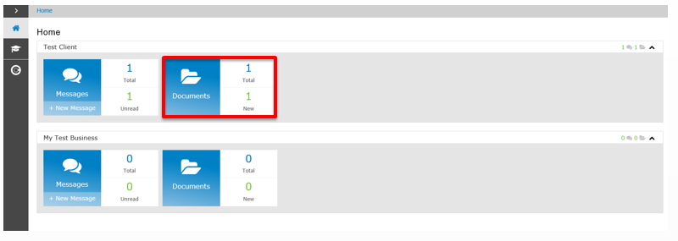

* Documents will be split out into folders (as specified by your accountant)

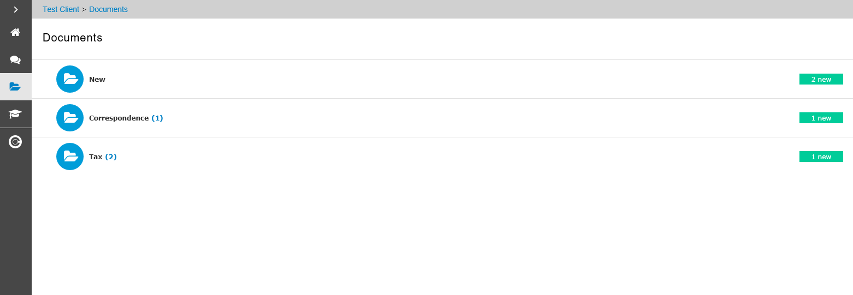

* Any documents needing your approval will be shown here

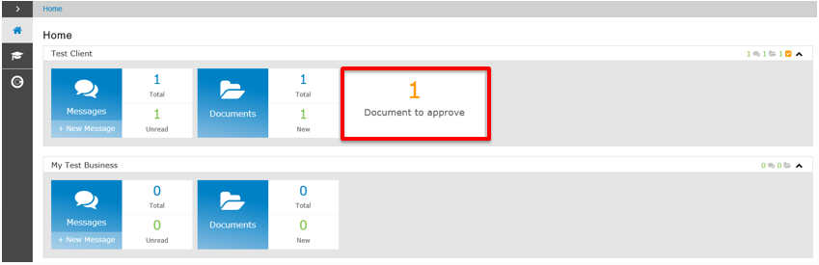

* Tick the checkbox and select Approve or Reject.
* You will need to enter your password to confirm your decision

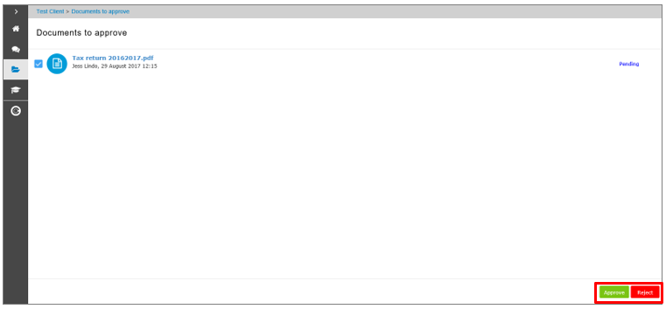

* Click here to return to your CCH OneClick Workspace

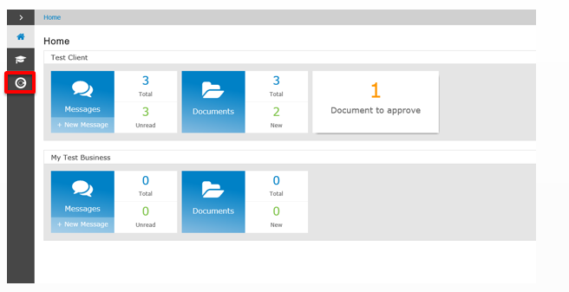

# Digital Data Request

* Digital Data Request will present you with a list of income sources from your accountant for which you need to provide data, along with any supporting documentation required
* It can be accessed using a browser-based application will be accessible through the Digital Data Request tile in your CCH OneClick workspace (if your practice has enabled this for you)

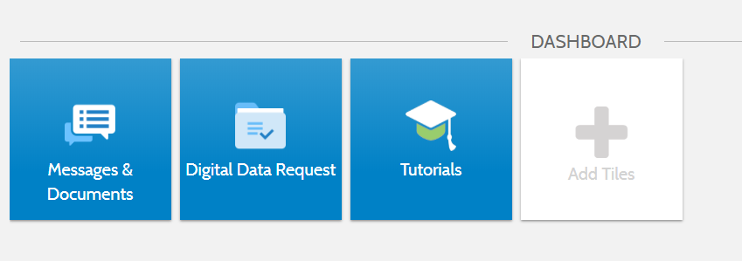

* Select the Digital Data Request tile in your CCH OneClick workspace



* If an information request has been sent, you will be presented with a list of items requiring action. If your practice has not sent you an information request, this screen will be blank

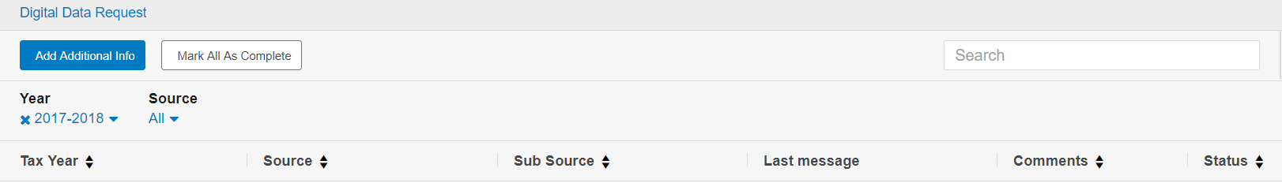

* Potential sources of income will include:-
  + Income from UK property
  + UK investment income
  + Employment income
  + Child benefit
  + Trading income
  + UK bank interest paid gross
  + Deductions
  + Foreign interest
  + Foreign dividend income
  + Other foreign income
  + Foreign state benefit income
  + Foreign pension income
* On all screens, please add the full amount of income and expenses
* The form will auto calculate your personal net income from this at the end based on the percentage %
* The drop downs can be used to filter on tax year and/or source of income

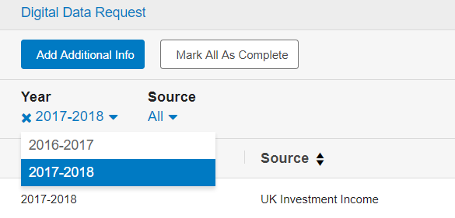

* Select a row to see that section
* When you open a section you can review the data which is displayed
* Some of the information may be pre-filled by HMRC and cannot be changed

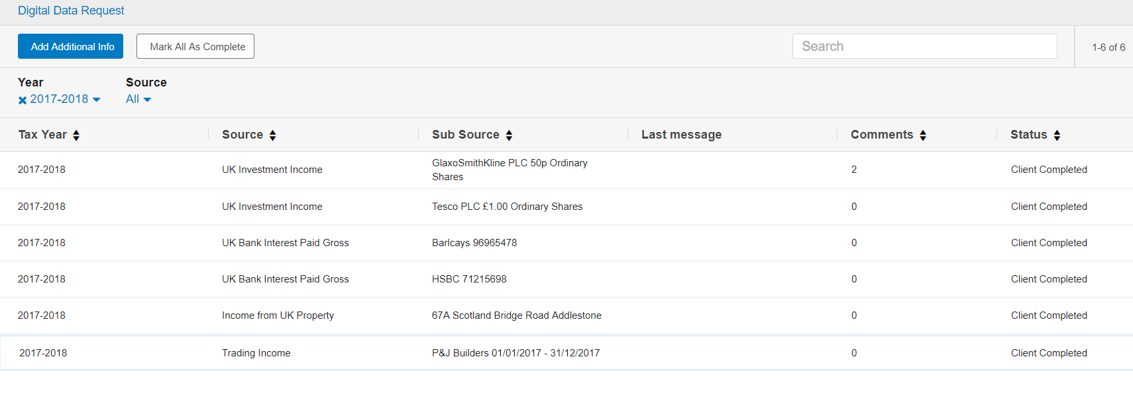

* When you click on a row the information will show on 3 tabs

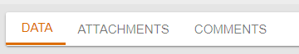

Data

* Review and make any required changes to the figures in each section (if applicable) then select **Save,** or **Cancel** to discard your changes

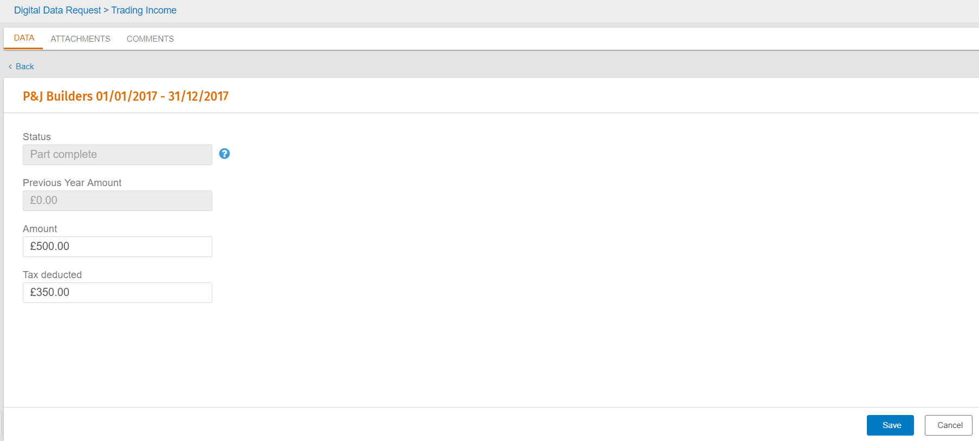

Attachments

* The attachments feature allows you to quickly attach documents to a section
* Use the **upload attachment** button to attach any relevant documents to each income source

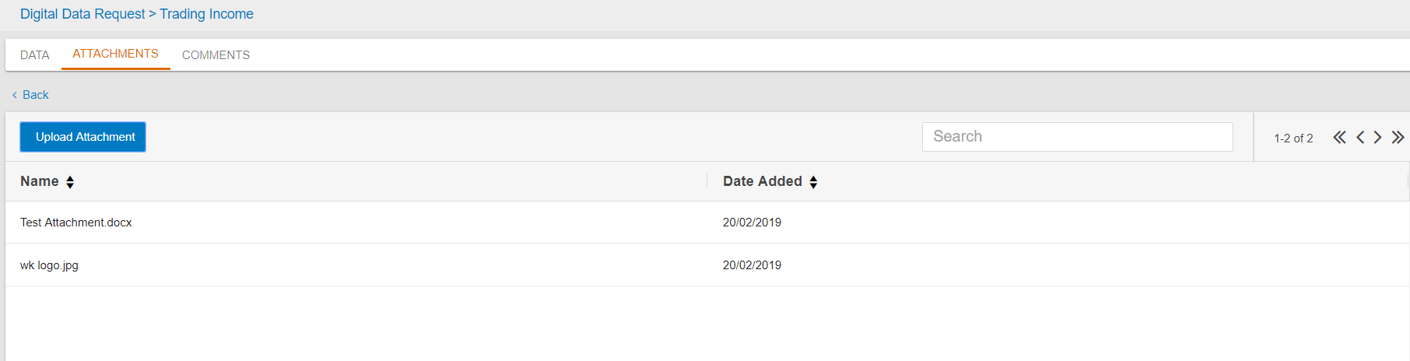

* Once uploaded, you can preview the attachment by selecting the relevant line

Comments

* The comments feature allows you to quickly send a message or comment about a particular section to the practice
* Select the **Add a comment** button to add a comment/message

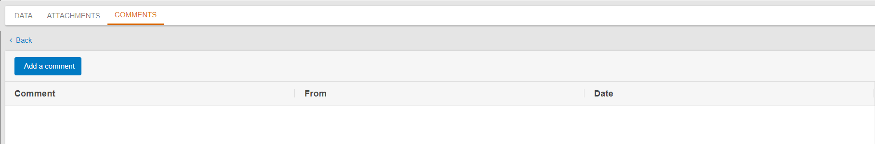

* Click **Save** to save your comment or **Cancel** to discard

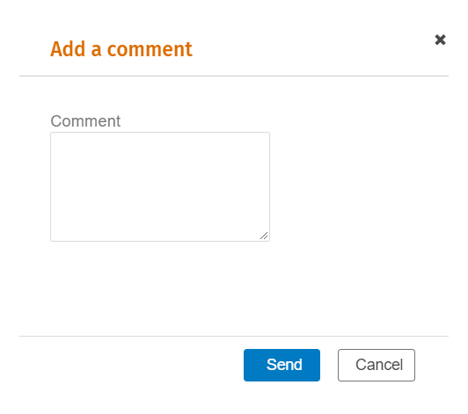

### Joint Income

* If a source of income is marked as joint this will be shown by the tick box being completed
* If there is a share /%  this will also be populated

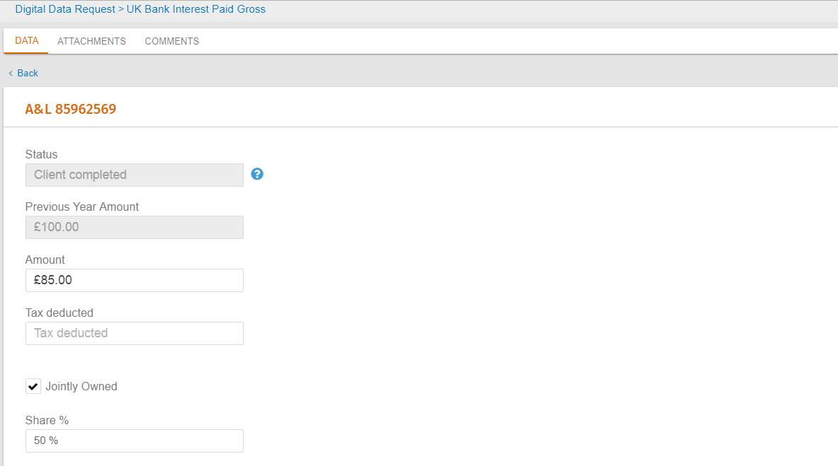

### Other foreign income

* The currency details will automatically be populated here if applicable

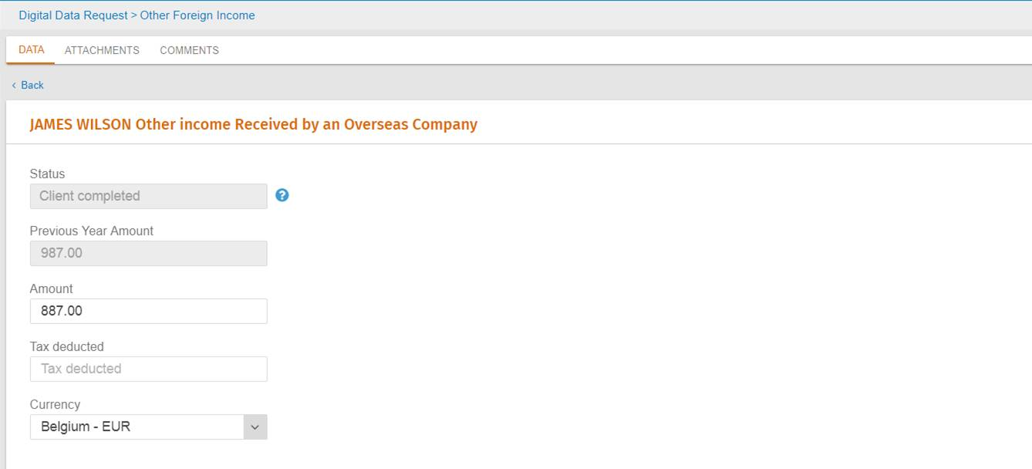

# VAT Returns

A separate guide to show you how to use the VAT Returns functionality can be found [here](https://userdocs.wolterskluwer.co.uk/@api/deki/files/15469/CCH_OneClick_-_MTDfV_guide_for_clients.pdf?origin=mt-web)