WKLogo_CMYK.eps

CCH Accounts Production

FRS 102 Master Pack 11.00 User Guide



Legal Notice

* + - Disclaimer

Wolters Kluwer (UK) Limited has made every effort to ensure the accuracy and completeness of these Release Notes. However, Wolters Kluwer (UK) Limited, its staff and agents will not be liable for any errors or omissions and use of the software is subject to the customer’s licence with Wolters Kluwer (UK) Limited. These Release Notes should not be relied upon as a detailed specification of the system or the software.

Wolters Kluwer (UK) Limited may make changes to these Release Notes from time to time.

* + - Copyright

These Release Notes may not be copied, altered, edited, disposed of or distributed without the prior consent of Wolters Kluwer (UK) Limited. The content is confidential.

Unless indicated otherwise all elements of this software product are owned by Wolters Kluwer (UK) Ltd.

© 2015 Wolters Kluwer (UK) Limited

* + - Trademark Rights

Microsoft, Windows, Windows NT, Windows for Workgroups, Windows 98, 2000, XP, MS-DOS, Windows Vista, Windows 7, Windows 8, Windows 10, Windows Server, Microsoft SQL Server, and Microsoft Office, are either registered trademarks or trademarks of Microsoft Corporation. Novell and NetWare are trademarks of Novell Inc. Citrix MetaFrame is a registered trademark or trademarks of Citrix Systems, Inc. All rights reserved.

All other trademarks are the property of their respective owners.

Wolters Kluwer (UK) Limited  
145 London Road,   
Kingston Upon Thames,   
Surrey   
KT2 6SR

Contents

[Release Highlights 1](#_Toc447274593)

[Prerequisites 1](#_Toc447274594)

[Scope 1](#_Toc447274595)

[CCH Accounts Production - FRS 102 Master Pack 2](#_Toc447274596)

[Client Creation 2](#_Toc447274597)

[Nominal Ledger 3](#_Toc447274598)

[Nominal Ledger Coding Structure 3](#_Toc447274599)

[Profit and Loss Account / Income Statement 3](#_Toc447274600)

[Balance Sheet / Statement of Financial Position 4](#_Toc447274601)

[Statutory Database 6](#_Toc447274602)

[Guidance Notes 6](#_Toc447274603)

[Trigger Questions 6](#_Toc447274604)

[Check Facilities 6](#_Toc447274605)

[Spare Notes 7](#_Toc447274606)

[Specific Areas of the Statutory Database 8](#_Toc447274607)

[1. Client Preferences 8](#_Toc447274608)

[1.1 Compliance terminology 8](#_Toc447274609)

[1.2 Implementation of FRS 102 - Reduced Disclosure Framework 9](#_Toc447274610)

[1.3 FRS 102 Section 1A - Small Companies Exemptions 10](#_Toc447274611)

[1.4 Exempt from Audit? 11](#_Toc447274612)

[1.5 Companies Limited by Guarantee 11](#_Toc447274613)

[1.6 Member of an ineligible group 11](#_Toc447274614)

[2. Accountant's Report 12](#_Toc447274615)

[3. Turnover 13](#_Toc447274616)

[4. Dividends 13](#_Toc447274617)

[5. Deferred Tax 14](#_Toc447274618)

[6. Presentation of Restatements 15](#_Toc447274619)

[Combined Income Statement / Changes in Equity 17](#_Toc447274620)

[Options 17](#_Toc447274621)

[Titles applied 17](#_Toc447274622)

[Statement of Cash Flows 18](#_Toc447274623)

[Format page and note (Page8cf and Note85) 18](#_Toc447274624)

[Statutory Database 18](#_Toc447274625)

[Management Accounts Collection 19](#_Toc447274626)

[Lead Schedule Collection 20](#_Toc447274627)

[Specific Functionality within the Financial Statements 22](#_Toc447274628)

[1. Multiple worksheets in a format 22](#_Toc447274629)

[2. Page orientation enhancement 23](#_Toc447274630)

[3. Set Title Rows - the ability to "repeat rows" at top of A4 page 24](#_Toc447274631)

[4. Statutory Ranges 25](#_Toc447274632)

[5. Comparative Statutory Values 26](#_Toc447274633)

[6. Excel Commands 26](#_Toc447274634)

[7. Column print conditions 26](#_Toc447274635)

[8. Warning Messages 26](#_Toc447274636)

[Transition to FRS 102 28](#_Toc447274637)

[Transitional procedures 28](#_Toc447274638)

[Required amendments – Retrospective restatement 28](#_Toc447274639)

[How to Disclose the Restatements within CCH Accounts Production 29](#_Toc447274640)

[1. Calculate the restatements required 29](#_Toc447274641)

[2. Posting Restatement Journals 29](#_Toc447274642)

[3. Analyse the Restatement Balances in Statutory Database 30](#_Toc447274643)

[4. Reconcile the "Transition To FRS 102" Format 32](#_Toc447274644)

[5. Amend the Cash Flow Statement 32](#_Toc447274645)

[6. Amend the Deferred Taxation analysis 33](#_Toc447274646)

[Prior Period Errors 34](#_Toc447274647)

[Known Issues 39](#_Toc447274648)

[Appendix 1 - Format Guide 40](#_Toc447274649)

[Appendix 2 - Adoption of the FRS102 standards by an existing UKGAAP job 43](#_Toc447274650)

[Appendix 3 - List of Statutory Database items converted to FRS102 for UK Limited companies 50](#_Toc447274651)

[Appendix 4 - FRS 102 Reporting Options 60](#_Toc447274652)

[Explanation of the Small Companies Exemptions, Abridged Accounts and Reduced Filing Copy. 60](#_Toc447274653)

[Appendix 5 - Companies Limited by Guarantee 66](#_Toc447274654)

[Appendix 6 - Compliance Terminology function 69](#_Toc447274655)

[Appendix 7 - Additional matters for Republic of Ireland 72](#_Toc447274656)

Release Highlights

Master Pack version 11.00 provides a number of format enhancements and corrections made since the previous release was issued.

Since the 2015.2 release of CCH Accounts Production we have provided the ability to convert your existing UKGAAP jobs onto the new FRS 102 pack. A series of conversion tools have been provided to help you efficiently move your existing UKGAAP jobs to the new FRS102 standards at the appropriate time.

These tools will convert the job's Trial Balance data, relevant Statutory Database data, as well as Saved Trial Balances or Budgets.

The new conversion tools are accessed during the Year End procedure.

Please see Appendices 2 and 3 for full details.

Prerequisites

The FRS 102 master pack 11.00 is only available to sites running CCH Accounts Production 2016.1 or above.

Scope

The FRS 102 master pack has some limitations of scope as set out below.

In this release, the master pack does NOT yet cater for the following:

* FRS102 Dormant companies
* Formatted Trial Balance
* 5 Year Summary report
* Assurance Report

These items will be provided in a future release.

# CCH Accounts Production - FRS 102 Master Pack

Client Creation

Once you have installed Accounts Production, you can set up a new FRS 102 Client as follows:

1) Create the Client in Central if it does not already exist.

2) On the Accounts Production tab, click in the grid to create a new accounting period:

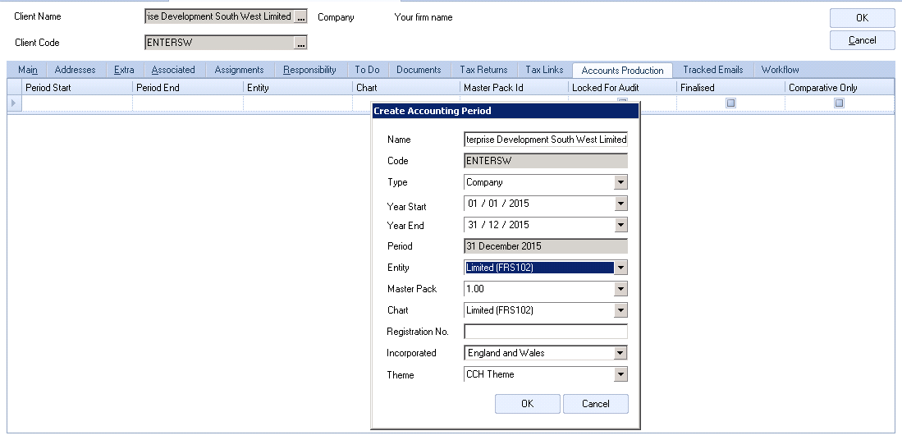

Type: select "Company".

Entity: select "Limited (FRS 102)".

Set other fields as required and click OK.

3) Double click the accounting period row on the grid to load the accounts production screen.

# Nominal Ledger

The nominal ledger structure used for FRS 102 companies differs from that used for standard ukgaap companies. The nominal ledger for FRS 102 companies is a 4 digit chart of accounts.

## Nominal Ledger Coding Structure

The nominal ledger coding structure adopted in these formats has been designed to cater for the requirements of FRS 102 and IFRS.

The nominal chart has the following key identifiers:

* Code ranges that group similar items together
* Descriptions that enable the user to understand the posting
* Category information which identifies where a posting will end up in the financial statements

The nominal chart is searchable both by browsing through codes and by entering text, and displays the 3 identifiers above, in data entry and information screens. Therefore, the entry of information is normally straightforward.

Note: Although sub codes have not been used within the master chart of accounts, users can always create them if further analysis is required.

The overall structure of the nominal ledger can be summarised as:

## Profit and Loss Account / Income Statement

|  |  |  |  |  |  |
| --- | --- | --- | --- | --- | --- |
| Turnover | 0001 - 049Z | Other gains and losses | 4400 - 449Z |  |  |
| Cost of sales | 0500 - 199Z | Finance costs | 4500 - 459Z |  |  |
| Distribution costs | 2000 - 299Z | Taxation | 4600 - 479Z |  |  |
| Administrative expenses | 3000 - 398Z | Discontinued activities | 4800 - 489Z |  |  |
| Exceptional items | 3990 - 399Z | Extraordinary items (FRS Only) | 4900 - 499Z |  |  |
| Other operating income | 4000 - 419Z | Retained earnings (SOCE) | 5000 - 589Z |  |  |
| Investment revenues | 4200 - 439Z | Income statement suspense | 5900 - 599Z |  |  |

## Balance Sheet / Statement of Financial Position

|  |  |  |  |  |  |
| --- | --- | --- | --- | --- | --- |
| Intangible assets | 6000 - 619Z | Non-current convertible loans note | 9160 - 916Z |  |  |
| Tangible assets | 6200 - 669Z | Non-current borrowings | 9170 - 929Z |  |  |
| Investment properties | 6700 - 674Z | Retirement benefits | 9300 - 939Z |  |  |
| Non-current financial assets | 6750 - 679Z | Deferred tax | 9400 - 944Z |  |  |
| Non-current derivatives | 6800 - 684Z | Provisions | 9450 - 948Z |  |  |
| Finance lease receivables | 6850 - 689Z | Liabilities associated with held for sale assets | 9490 - 9498 |  |  |
| Investment in group companies | 6900 - 699Z | Share based payment liability | 9499 - 949Z |  |  |
| Inventories | 7000 - 709Z | Ordinary shares | 9500 - 959Z |  |  |
| Trade and other receivables | 7100 - 749Z | Preference shares | 9600 - 969Z |  |  |
| Current asset investments | 7500 - 751Z | Equity reserve | 9700 - 970Z |  |  |
| Short term investment in groups (FRS only) | 7520 - 759Z | Share Premium | 9710 - 971Z |  |  |
| Short term investments (FRS Only) | 7600 - 769Z | Revaluation reserve | 9720 - 9734 |  |  |
| Current derivatives | 7700 - 779Z | Capital redemption reserve | 9735 - 973Z |  |  |
| Cash and cash equivalent | 7800 - 789Z | Own shares reserve | 9740 - 9744 |  |  |
| Assets held for sale | 7900 - 799Z | Other reserves | 9745 - 975Z |  |  |
| Current trade and other payables | 8000 - 814Z | Hedging reserve | 9760 - 976Z |  |  |
| Current tax liabilities | 8150 - 819Z | Non-controlling interests | 9770 - 979Z |  |  |
| Current borrowings | 8200 - 889Z | Spare Reserves (future development) | 9780 - 989Z |  |  |
| Non-current borrowings | 9000 - 906Z | Retained earnings | 9900 - 990Z |  |  |
| Non-current trade and other payables | 9070 - 912Z | Spare Reserves (future development) | 9910 - 989Z |  |  |
| Non-current tax liabilities | 9130 - 915Z | SOFP/Balance sheet suspense | 9990 |  |  |

### IFRS Only Codes

Some of the nominal codes that exist in the FRS 102 chart of accounts are present only to align the chart with the IFRS chart of accounts. These codes are clearly marked "IFRS only" in both the Nominal Description and the Chart Category;

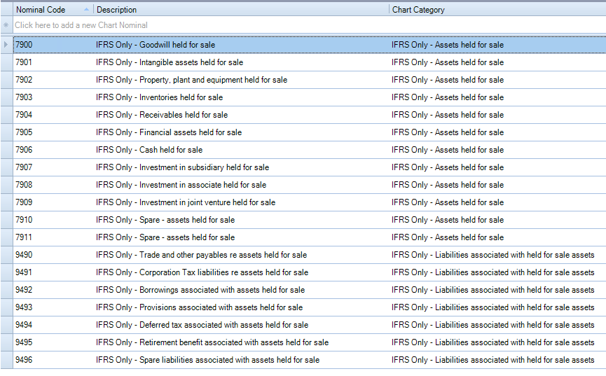

You should not post any transactions within FRS 102 accounting periods to such nominal codes.

If you do, the formats will print a warning message to alert you. For example;



# Statutory Database

Within the FRS 102 Master Pack, we have implemented some new features within the Statutory Database:

## Guidance Notes

Built within certain nodes of the Statutory Database, we have implemented 'Guidance Notes', which are there to help the user understand the information that needs to be disclosed within the particular node:

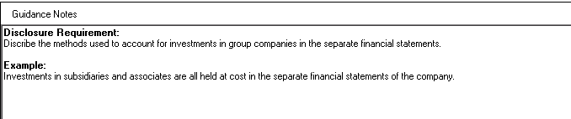

## Trigger Questions

Built within certain nodes of the Statutory Database, we have implemented 'Trigger Questions', these are designed to help the user mould the database and formats depending on how the questions are answered.

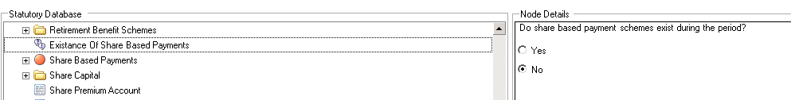

## Check Facilities

Built within the following nodes of the Statutory Database is a check facility, which ensures that the information disclosed in the database agrees to the trial balance:

* Profit and Loss Account / SOCI Notes - Turnover - Analysis of Turnover
* Profit and Loss Account / SOCI Notes - Dividends - Ordinary Shares - Final and Interim Dividends
* Profit and Loss Account / SOCI Notes - Dividends - Preference Shares - Final and Interim Dividends
* Profit and Loss Account / SOCI Notes - Impairments - Analysis of Impairments
* Profit and Loss Account / SOCI Notes - Impairments - Analysis of Reversal of Previous Impairments
* Balance Sheet / SOFP Notes - Finance Lease Receivables - Minimum Lease Payments
* Balance Sheet / SOFP Notes - Finance Lease Obligations - Minimum Lease Payments
* Balance Sheet / SOFP Notes - Finance Lease Obligations - Present Value
* Balance Sheet / SOFP Notes - Deferred Tax - Deferred Tax Movements
* Balance Sheet / SOFP Notes - Retirement Benefit Schemes - Defined Benefit Schemes - Obligation Split

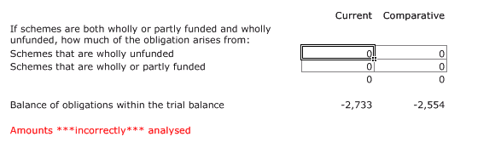

## Spare Notes

Within the FRS 102 Master Pack, we have implemented a new approach to handling "Spare Notes". It is now possible in CCH Accounts Production to trigger a spare note to print by populating the Header and Text within the Statutory Database.

This approach has been implemented on the following areas within the Statutory Database:

* Critical Accounting Estimates
* Profit and Loss Account / SOCI Notes
* Balance Sheet / SOFP Notes
* Other Notes

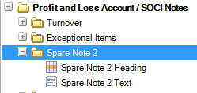

In total there are 26 Spare Notes across the database.

# Specific Areas of the Statutory Database

## 1. Client Preferences

The Client Preferences node offers a series of questions to help you tailor the accounts:

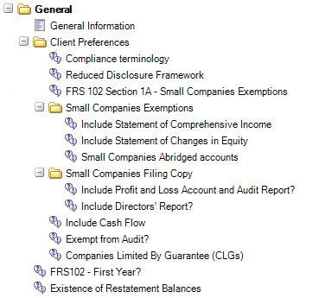

## 1.1 Compliance terminology

Within the FRS 102 Master Pack, we have implemented a new approach to handling compliance terminology. It is now possible in CCH Accounts Production to specify the terminology you wish to use at client level.

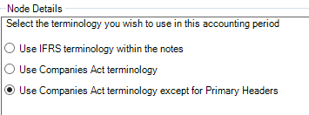

* Use IFRS terminology within the notes - This option will use IFRS terminology throughout the financial statements, both in the primary statements and notes, i.e. instead of seeing Stocks you will see Inventories
* Use Companies Act terminology - This option will use Companies Act terminology throughout the financial statements, both in the primary statements and notes, i.e. instead of seeing Inventories you will see Stocks.
* Use Companies Act terminology except for Primary Headers - This option will use Companies Act terminology throughout the financial statements, both in the primary statements and notes, i.e. instead of seeing Inventories you will see Stocks. The only change is that the header for Profit and Loss Account and Balance Sheet will change to Income Statement and Statement of Financial Position.

More detail on how to use, edit and control the Compliance Terminology function is contained in Appendix 6 below.

Compliance Terms Lookup

A user who does not have the Task Permission to access the Compliance Terminology maintenance screen may easily check the list of available terms while editing a format by selecting the "Compliance Terms" action on the task bar:

Classic mode: Ribbon mode:

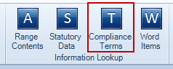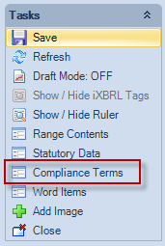

New Commands

There are new commands within the formats that allow users to reference the Compliance Terminology:

* =AP("#Term1") - This is used within the body of a format or within a paragraph.
* =AP("#TermH1") - This is used within the header of a format. (It is the same value as #Term1, the "H" informs the application that the command has been used in the Header of the format)
* =AP("#CustomTerm") - May be added by users if required.

## 1.2 Implementation of FRS 102 - Reduced Disclosure Framework

If the company for which you are preparing FRS 102 accounts is a qualifying entity (broadly speaking a subsidiary of a parent company who reports under FRS 102), it is possible to take some exemptions from certain disclosures (for example exemption from cash flow).

Simply select the Yes option:

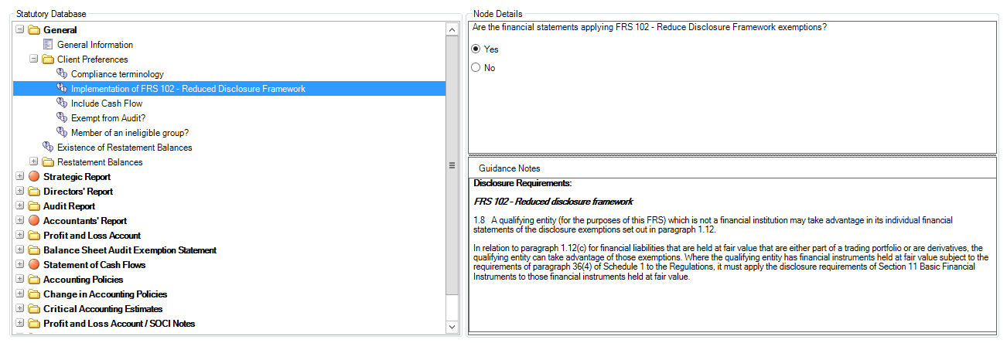

Once 'Yes' has been selected, further questions will appear, e.g. 'Include Cash Flow', 'Disclosure of Financial Instruments'. Additionally, areas that are optional fields to be disclosed are now identified with a 'blue no-entry' symbol throughout the Statutory Database.

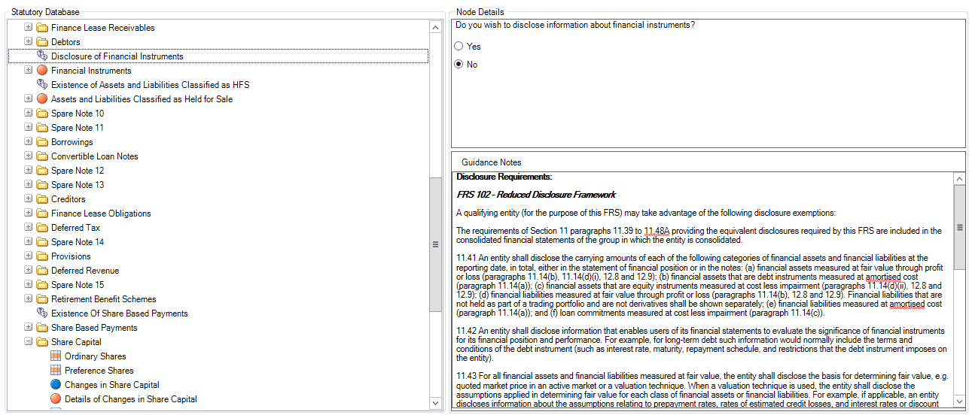

The Cash Flow Statement is not required by FRS 102 - Reduced Disclosure Framework, but it can be optionally disclosed by answering ‘yes’ to the statutory database question “Include cash flow?” under Client Preferences node:

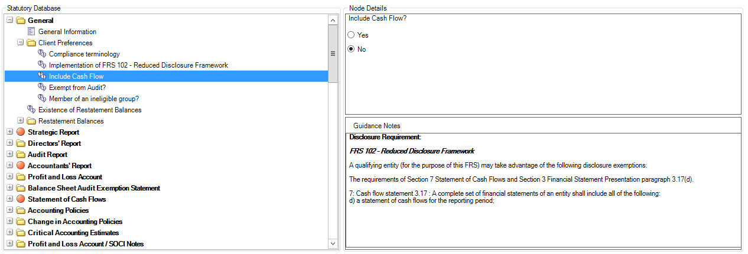

## 1.3 FRS 102 Section 1A - Small Companies Exemptions

The “small entities regime” (Section 1A of the FRS102 legislation) is available to companies which qualify as a small entity. It allows the accounts to benefit from a series of reporting exemptions. If the small companies exemptions are applied, then many of the formats will no longer be included in the print, and others will become less detailed.

Further details are explained in Appendix 4 below.

## 1.4 Exempt from Audit?

Within the FRS 102 Master Pack, we have implemented a new approach to handling audit requirements. It is now possible in CCH Accounts Production to specify the level of exemption from audit you wish to use for the accounting period;

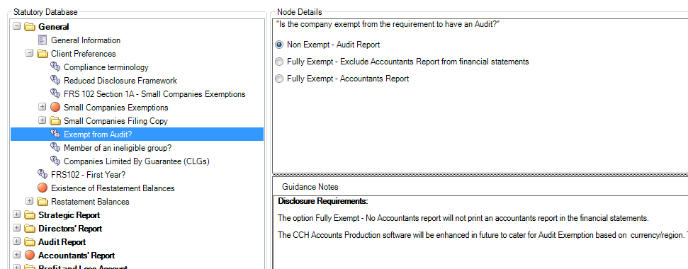

## 1.5 Companies Limited by Guarantee

The Limited (FRS 102) master pack 7.00 and above supports the generation of accounts for Companies Limited by Guarantee (CLG), incorporated in either the United Kingdom or the Republic of Ireland.

Please see Appendix 5 for more detailed guidance.

Note - The production of CLG accounts will be controlled via your CCH Licence in future. In this release, the option is available to all users if you wish to try it out, but in future you will only be able to continue to access this if you are correctly licenced.

## 1.6 Member of an ineligible group

If the company is a subsidiary of an ineligible group (broadly if one of the members of the group is a Plc), it does not have to include a Strategic Report within its own accounts.

This will also trigger an extra bullet point in the Audit Report Matters section and supresses other references to the Strategic Report.

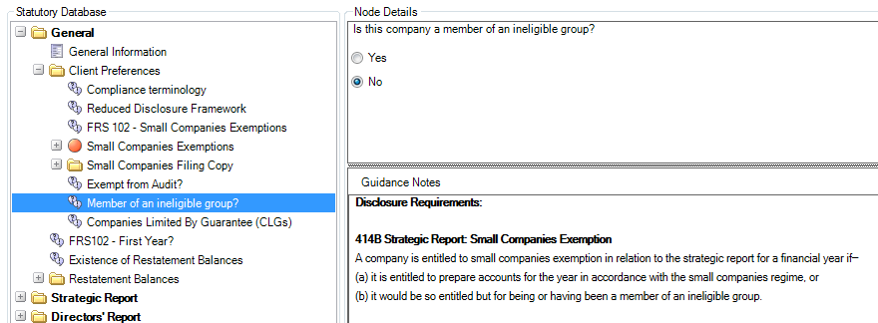

## 2. Accountant's Report

The new FRS102 master packs include Accountant's Report paragraphs with the correct wording required for 6 different professional accountancy bodies:

1. Association of Chartered Certified Accountants (ACCA)

2. Institute of Chartered Accountants in England and Wales (ICAEW)

3. Chartered Accountants Ireland (CAI)

4. Institute of Chartered Accountants in Scotland (ICAS)

5. Institute of Incorporated Public Accountants (IPA)

6. Institute of Certified Public Accountants (CPA)

Within the Statutory Database, you may select the correct body by entering the corresponding number into the grid as shown below. This will refresh the Statutory Database and trigger the correct paragraphs to be automatically selected in the Accountants Report section.

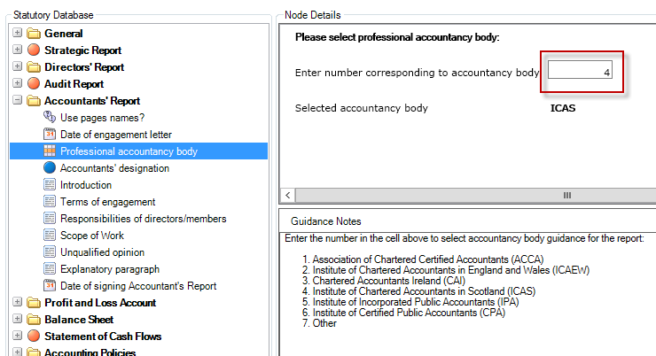

There is a task permission applied to this node: #Client #Can Edit Accountancy Body. Only users who have this permission may amend the value.

Additionally, you can specify a default value for your firm which will be applied to any new clients that you create in CCH Accounts Production.

Open Maintenance > Accounts > Statutory Database Defaults and use the drop down list to select the correct default for your firm.

## 3. Turnover

### Analysis of Turnover

Within the Statutory Database: Profit and Loss / SOCI Notes>Turnover>Analysis of Turnover, it is important that the user populates the grid with the categories of turnover, even if there is only 1 category of turnover. This information is then used to populate the Turnover note, the information is not taken from the nominal ledger (nominal codes 0001 - 049Z).

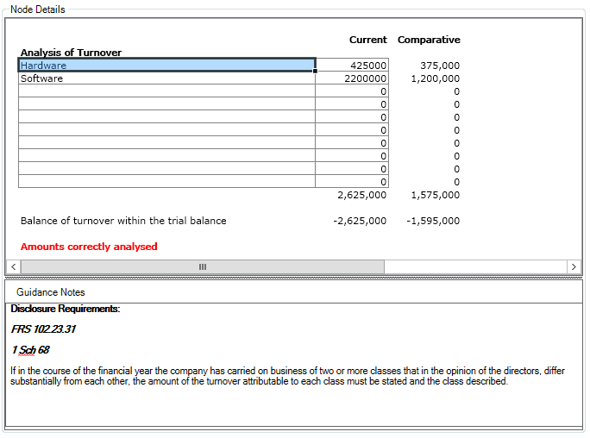

## 4. Dividends

When posting dividends we have tried to simplify the nominal ledger and therefore there are only 4 nominal codes that can be posted to:

* 5001 - Ordinary dividends final paid
* 5002 - Ordinary dividends interim paid
* 5003 - Preference dividends final due or paid
* 5004 - Preference dividends interim paid

All analysis work is done within the Statutory Database: Profit and Loss Account / SOCI Notes>Dividends>Ordinary/Preference Shares> Final/Interim Dividends:

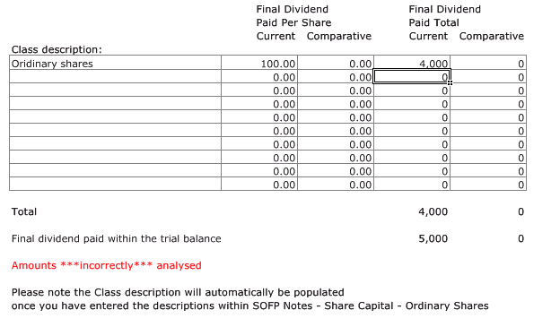

## 5. Deferred Tax

When posting deferred tax we have tried to simplify the nominal ledger and therefore there are only 3 areas that can be posted to:

* 9400-940Z Deferred tax liability balances not offset (one code for each jurisdiction)
* 9410-941Z Deferred tax asset balances not offset (one code for each jurisdiction)
* 9420-944Z Spare codes (currently treated as asset balances)

If balances can be offset, then they should be entered in the same range. For instance, if there is a liability for £300,000 and a separate asset of £100,000 which can be offset, they should be entered (say) as 9400 £300,000 Cr and 9401 £100,000 Dr.

If asset and liability balances cannot be offset and must be disclosed separately under IAS 12, they are entered in the separate asset and liability ranges.

All analysis work is done within the Statutory Database: Balance Sheet / SOFP Notes>Deferred Tax:

There is one grid (Balance Sheet / SOFP Notes>Deferred Tax>Deferred Tax Headings) that permits the amendment of the standard category descriptions for the breakdown of the balances and movements (e.g. ACAs, Tax losses, Revaluations).

A second grid (Balance Sheet / SOFP Notes>Deferred Tax>Deferred Tax Movements) permits entry of:

* Movements during the year, analysed by category as above and the type of movement (e.g. Credit to profit and loss, Credit to OCI):
* Closing balances, with separate lines for liabilities and assets. As for the nominal codes, the separate lines should only be used where the balances cannot be offset and must be disclosed separately under IAS 12.

This second grid has checks built in to show differences from the nominal and differences in each category total.

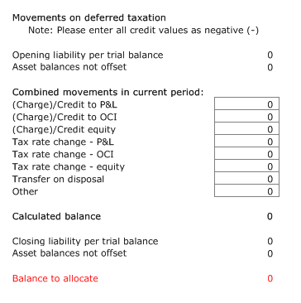

## 6. Presentation of Restatements

Any restatements that are disclosed upon adoption of the FRS102 standards may be presented in the accounts in three possible ways:

* A summarised "list" of the restatements
* A detailed breakdown of the movements resulting from the restatements
* Both of the above

The default presentation used is the "list" option, but this may be altered in the Statutory Database screen:

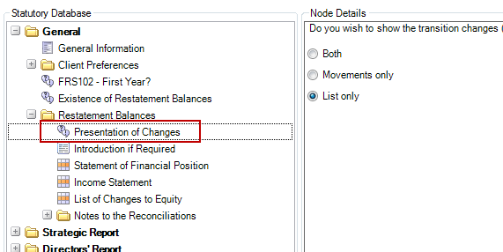

An example of the reconciliation of equity note when using "list mode" is shown below:

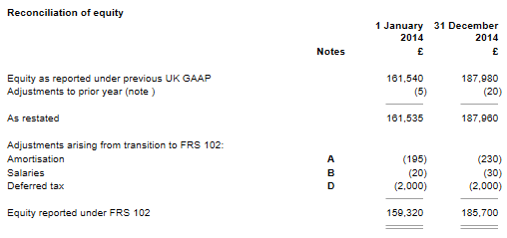

An example of the same note when using "movements mode" is shown below:

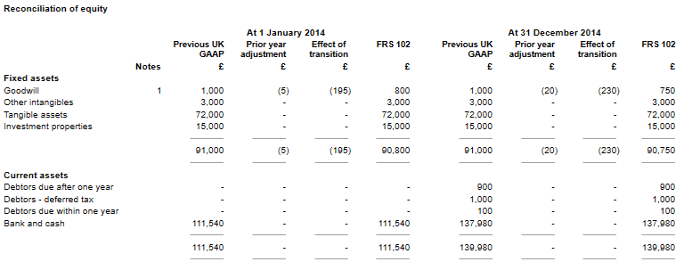

An explanation of the transition entries to be made is set out in the section on transition adjustments starting on page 28 below.

An explanation of the entries to be made for prior period error adjustments and their interaction with transition adjustments is set out in the section on prior period adjustments starting on page 34 below.

# Combined Income Statement / Changes in Equity

## Options

FRS 102 permits three options:

* Three separate statements: income statement: statement of comprehensive income: statement of changes in equity.
* The first two are combined into a single statement of comprehensive income, with a separate statement for changes in equity.
* The three are combined into a statement of income and retained earnings.

In the Master Pack, the default is the first option (show all three statements). The second and third options can be chosen in the statutory database under the "Profit and Loss Account" heading. For each option, the statutory database displays guidance taken from FRS 102.

The third option is permitted only where there are no movements on other comprehensive income and the only changes to equity for all periods presented arise from profit or loss, payment of dividends, corrections of prior period material errors, and changes in accounting policy.

Note that if the third option is wrongly chosen (e.g. where there exists other comprehensive income) a warning message is triggered on the income statement format.

## Titles applied

Compliance terminology options are available for the "Income statement". However, where a combined statement has been chosen (options 2 & 3 above), the titles used for the formats default to the specific FRS 102 names "Statement of comprehensive income" and "Statement of income and retained earnings ".

# Statement of Cash Flows

## Format page and note (Page8cf and Note85)

Within the FRS 102 Master Pack, we have implemented a format page for the cash flow statement itself and for the key reconciliation note which shows the adjustments between the profit and the figure for cash generated from operations which is the starting point of the main cash flow statement.

In compiling these formats, we have used Excel-style cell references, including within variable text calculations.

## Statutory Database

Within the statutory database additional information is to be added, and therefore the cash flow has been broken down into the following areas:

* Financing Activities
* Non-Cash and Non-Operating
* Investing Activities
* Finance Lease Additions
* Roundings

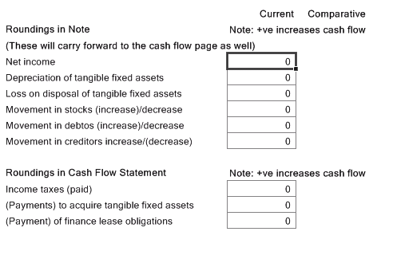

# Management Accounts Collection

A new "Management" collection has been added to the Limited (FRS 102) master pack to provide the following Management Report formats:

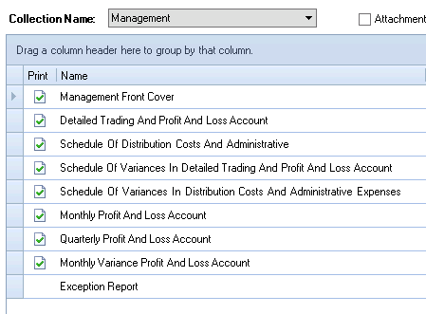

# Lead Schedule Collection

On the Financial Statements screen, a new collection is available in Master Pack 9.00 and above that provides a comprehensive set of Lead Schedule formats.

The collection consists of “main” schedules (in upper case), and backing schedules.

The statutory database contains new nodes to facilitate entering information which is then displayed on the lead schedules;

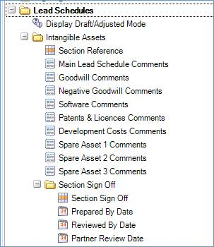

An example of a Main Lead Schedule is shown below;

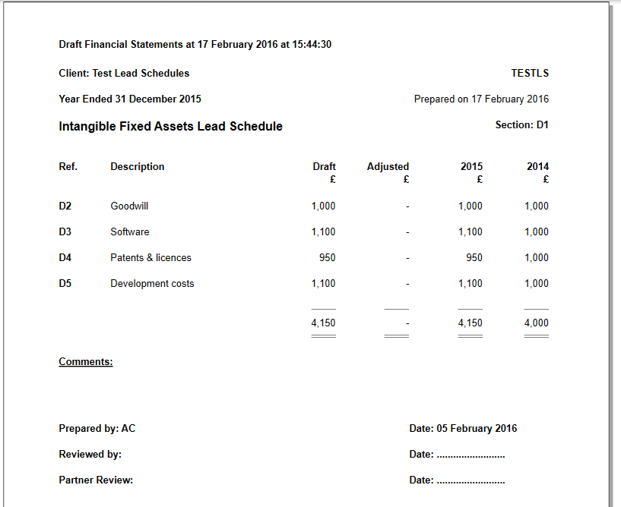

# Specific Functionality within the Financial Statements

Notes are included below only where the formats are significantly different from those found in standard ukgaap Limited Company financial statements.

## 1. Multiple worksheets in a format

Within the FRS 102 Master Pack, we have implemented a new approach to handling "attachment" formats. It is now possible in CCH Accounts Production to add multiple worksheets to a format, and to trigger the printing of each worksheet based on a test condition.

You will now observe a new group of actions displayed on the task bar when editing a format:

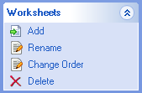

These allow a user to maintain multiple worksheets within the format. This may prove useful when designing a format in which the number of columns varies within the format. This is an alternative approach to handling "attachment" formats, which is less complicated.



There are some new variations of the existing Attach command available to control the printing of multiple worksheets within a Format:   
  
1) indirect format reference:   
=AP("\*Attach\*,page4dir,(f1=f1)")  
  
Works the same as in previous CCH Accounts Production releases. Attaches a format but from now on it attaches all worksheets within the attached format.  
  
2) indirect worksheet reference:  
=AP("\*Attach\*,page4dir@Sheet3,(f1=f1)")  
  
Attaches from format "page4dir" the worksheet named "Sheet3".  
  
3) relative worksheet reference:  
=AP("\*Attach\*,@Sheet3,(f1=f1)")   
  
Attaches from current format the worksheet named "Sheet3".

This approach has been implemented on the following FRS 102 formats:

* Income Statement (page6is)
* Statement of Financial Position (page7sofp)
* Taxation (note18)
* Discontinued operations (note19)
* Dividends (note21)
* Intangible assets (note25)
* Tangible assets (note26)
* Finance lease receivables (note33)
* Finance leases commitments (note47)
* Deferred taxation (note48)
* Provisions (note50)
* Retirement Benefit Schemes (note53)
* Share-based payment transactions (note54)
* Acquisitions of a business (note65)
* Disposal of a business (note66)
* Operating leases commitments (note69)
* Related party transactions (note74)

## 2. Page orientation enhancement

Within the FRS 102 Master Pack, we have implemented a new approach to handling the orientation of a format. When editing a format, in the Page Setup screen there is a new option for orientation called "Autodetect".

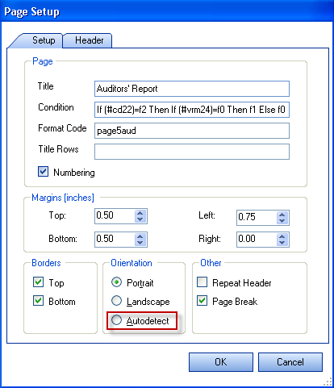

If Autodetect is selected, when the format is previewed CCH Accounts Production will calculate the required width of the content to be printed. If it can fit onto a portrait A4 page, the preview will automatically show as portrait. If the content is too wide, the orientation will be automatically switched to landscape.

This approach has been implemented on the following FRS 102 formats:

* Statement of Changes in Equity (page7soce)
* Intangible assets (note25)
* Tangible assets (note26)

## 3. Set Title Rows - the ability to "repeat rows" at top of A4 page

Within the FRS 102 Master Pack, we have implemented the ability to repeat rows at the top of a page or note. For example you may have a management page or a tangible fixed asset note that goes on to two pages and you wish to repeat the same 'heading' rows on the second page.

To use this function, open the page or note and select Draft Mode. Highlight the rows you wish to repeat, right click and select "Set title rows…".

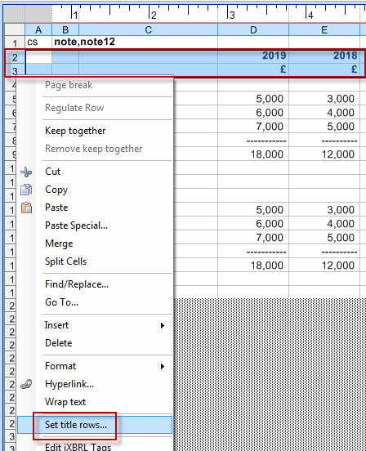

This will display a small pop up window, showing the rows you have selected. To accept this, press "Enter" to set the title rows.



Alternatively, click the red "X" to cancel.

A tooltip will be added to the cell to indicate the title rows:

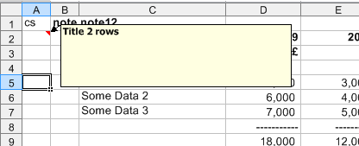

To remove title rows once set, right click and select "Set title rows…" again, and this time click the "Clear" button in the pop up window:



This approach has been implemented on the following FRS 102 formats:

* Statement of Changes in Equity (page7soce)
* Intangible assets (note25)
* Tangible assets (note26)

## 4. Statutory Ranges

Within the FRS 102 Master Pack, we have implemented a new approach to handling statutory database field references. It is now possible in CCH Accounts Production to add/subtract statutory database fields and cross reference them in a format. Within Maintenance > Accounts > Statutory Ranges:

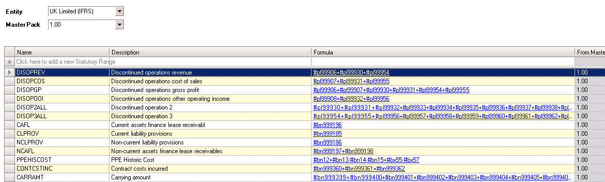

There is a new command within the formats that allows users to reference to a Statutory Range:

=APSTATRANGE("a","CAFL")

This command can be used on its own or within a print condition or with name ranges e.g.

=AP("[a,\*TOTREV]")-APSTATRANGE("a","DISOPREV")

## 5. Comparative Statutory Values

Within the FRS 102 Master Pack, we have implemented a new approach to handling statutory database field references in relation to comparative values. Rather than have alternative #commands for comparative values, it is now possible in CCH Accounts Production to use the same #command for both current and comparatives etc.

For example, the number of employees is contained in statutory item #on57. The following commands may be used:

=AP("b,#on57")

Within the above command you can reference to:

* a = Current accounting period.

Please note =AP("#on57"), will also return the number of employees for the current accounting period and this is the default entry used in the CCH FRS 102 Master Pack.

* b = Comparative accounting period
* c = Pre-comparative accounting period and so on

This command can be used on its own or within a print condition or with name ranges.

## 6. Excel Commands

Within the FRS 102 Master Pack, we have implemented a new approach to handling certain formula commands within formats. Where possible we have implemented standard Excel commands, for instance =Sum, =Countif commands etc.

## 7. Column print conditions

Within the FRS 102 Master Pack, we have implemented a new approach to handling print conditions within column A of the formats. Previously, users would see 'zero' or 'not zero' which were used to identify where or not a row should or shouldn't print. These commands have now been updated and within column A of the formats, you will either see 'print' (when the row is going to print) or 'rs' (when the row will not be printing).

## 8. Warning Messages

Within the FRS 102 Master Pack, we have implemented warning messages that will print within specific formats.

### **Statement of Financial Position (Page7sofp) - Spare Reserves**

Within the FRS 102 Master Pack, there is space in the chart for nominal codes 9780..989Z and 9910..998Z. These are earmarked for future development and should not be posted to within FRS 102.

Therefore, if a user posts to these nominal codes a warning message will appear at the bottom of the Statement of Financial Position page advising the user to reconsider posting.

### **Intangible Assets (Note25) - Spare Nominal Codes**

Within the FRS 102 Master Pack there is space in the chart for intangible assets for codes 6160..619Z. These are earmarked for future development and should not be posted to within FRS 102. If these codes are posted to then they will appear within the Total Net Book Value column but not within the analysis.

Therefore, if a user posts to these nominal codes a warning message will appear at the bottom of the Intangible Assets note advising the user to reconsider posting.

### **Tangible Assets (Note26) - Spare Nominal Codes**

Within the FRS 102 Master Pack there is space in the chart for tangible assets for codes 6530..669Z. These are earmarked for future development and should not be posted to within FRS 102. If these codes are posted to then they will appear within the total net book value column but not within the analysis.

Therefore, if a user posts to these nominal codes a warning message will appear at the bottom of the Tangible Assets note advising the user to reconsider posting.

### **Investment Properties (Note27) - Spare Nominal Codes**

Within the FRS 102 Master Pack there is space in the chart for investment properties for codes 6730..674Z. These are earmarked for future development and should not be posted to within FRS 102. If these codes are posted to then they will appear within the carrying value row but not within the analysis.

Therefore, if a user posts to these nominal codes a warning message will appear at the bottom of the investment property note advising the user to reconsider posting.

# Transition to FRS 102

The FRS 102 legislation states:

Section 35 Transition to this FRS of FRS 102 The Financial Reporting Standard applicable in the UK and Republic of Ireland applies to the first-time adoption of FRS 102 and sets out how an entity prepares its first financial statements that conform with that standard.

FRS 102 will be effective for accounting periods beginning on or after 1 January 2015, although early application is permitted. It requires the comparative and opening balance sheet at the date of transition to be restated in accordance with FRS 102: the date of transition being the beginning of the earliest period for which an entity presents full comparative information. However, the opening balance sheet itself does not need to be presented.

FRS 102 requires the presentation of reconciliations of equity determined in accordance with its previous financial reporting framework and its equity determined in accordance with FRS 102 at two dates:

(a) the date of transition to FRS 102: and

(b) the end of the latest period presented in the entity’s most recent annual financial statements determined in accordance with its previous financial reporting framework.

FRS 102 requires the presentation of a reconciliation of profit or loss determined in accordance with its previous financial reporting framework for the latest period in the entity’s most recent annual financial statements to its profit or loss determined in accordance with FRS 102 for the same period.

For example, for an entity with a 31 December year end, the first year of mandatory application will be the year ending 31 December 2015. The entity will need to restate its opening balance sheet at the date of transition (e.g. at 1 January 2014) and comparative balance sheet (e.g. at 31 December 2014) in accordance with FRS 102, although the opening balance sheet need not be presented. The entity will need to prepare reconciliations of equity at 1 January 2014 and 31 December 2014 and of its profit or loss for the year ending 31 December 2014.

## Transitional procedures

FRS 102 requires the balance sheet at the date of transition to be prepared in accordance with the recognition and measurement requirements of FRS 102.

## Required amendments – Retrospective restatement

For an entity with a date of transition of 1 January 2014, it is required to restate its balance sheet at 31 December 2013 by making the adjustments that are necessary to recognise and measure all assets and liabilities in accordance with FRS 102.

Paragraph 35.7 of FRS 102 requires an entity to:

(a) recognise all assets and liabilities whose recognition is required by FRS 102 (e.g. forward exchange contracts):

(b) not recognise items as assets or liabilities if FRS 102 does not permit their recognition:

(c) reclassify items (e.g. into different groupings in the cash flow statement): and

(d) restate certain assets and liabilities at a different value (e.g. financial instruments measured at amortised cost using the effective interest rate, which in some cases may vary from a previously used historical cost).

Paragraph 35.8 states that adjustments on transition shall be recognised in retained earnings, or where appropriate, another category within equity.

## How to Disclose the Restatements within CCH Accounts Production

There is a 5 step process to follow when disclosing the restatements involved during the conversion to FRS 102:

1. Calculate the restatements required for prior year for the specific job.

2. Post a Restatement journal within CCH Accounts Production in the current year.

3. Analyse out the detail within the Statutory Database in the current year.

4. Reconcile the Transition Reconciliation format.

5. Make cash flow adjustments where required.

## 1. Calculate the restatements required

This step is done externally to CCH Accounts Production, and relies on your knowledge of the company and its financial affairs.

## 2. Posting Restatement Journals

Once you have identified the restatements that are relevant, you need to post a Restatement Journal into CCH Accounts Production within the current year. (Restatement journals are entered in the current year because they will affect the comparative year figures only when viewed in the current year financial statements: they will not be seen in the comparative year when that is opened directly).

This can be done via the usual Journal Entry screen, by first amending the Type from "Journal" to "Restatement":

(Note: Restatement journals will only be available if a comparative accounting period is present).

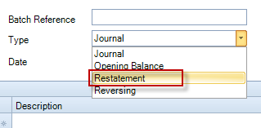

The cumulative effect of the opening and closing balances restatements for the comparative period should be posted. For example, if the value of investments is increased by £3,000 at the start of the comparative period (i.e. uplifted from the original closing balance of the pre-comparative period) and is then increased by a further £2,000 at the end of the comparative period, then the restatement journal should be the total of £5,000.

Note that for reserves, you need to distinguish between adjustments to the (prior year) opening balance and the movements in the year. If for instance the uplift in value of the investments noted above passes through a revaluation reserve, then £3,000 will be posted as a credit to the opening balance for that reserve and £2,000 will be posted to the nominal code for the movement during the year.

A new command has been created to return the balance of the Restatement Journals posted to a given nominal code or Name Range. This command is used in formats relating to the transition to FRS 102 in the new master pack. This new command has been added to CCH Master Formats as required and users do not need to edit their own formats.

The command uses the same notation as the existing Name Range total, but is prefixed by a ~ (tilde) character which tells CCH Accounts Production to only return the balances of any Restatement Journals entered. For example:

=AP("~[b\*,TO]")

Because the restatement journals by their nature affect the comparative period values, the new command requires you to enter period b rather than a.

Note: The effect of the restatement journals need to be reflected in the current year entries. For instance, if the closing balance of the Revaluation reserve has been uplifted by £5,000 in the prior year, then the current year opening balance of that reserve needs to have been updated to agree to this new figure. Therefore, where the current year figures have been created by rolling forward from an un-restated prior year (or by manual entry of the same), an opening balance journal will be required in the current year.

## 3. Analyse the Restatement Balances in Statutory Database

Paragraph 35.13 states that to comply with the disclosure of transition to FRS 102 an entity's first financial statements prepared using the FRS shall include:

* A description of the nature of each change in accounting policy.
* Reconciliations of its equity determined in accordance with its previous financial reporting framework to its equity determined in accordance with this FRS for both of the following dates:
  + The date of transition to this FRS: and
  + The end of the latest period presented in the entity's most recent annual financial statements determined in accordance with its previous financial reporting framework.
* A reconciliation of the profit or loss determined in accordance with its previous financial reporting framework for the latest period in the entity's most recent annual financial statements of its profit or loss determined in accordance with this FRS for the same period.

To cater for the above, within the General Node there is a flag 'Existence of Restatement Balances'. Once 'Yes' has been selected a further node is available 'Restatement Balances', within this node there are 3 options:

* Statement of Financial Position - Reconciliation of Equity
* Income Statement - Reconciliation of profit or loss for the year
* List of Changes to Equity
* Notes to the Reconciliation

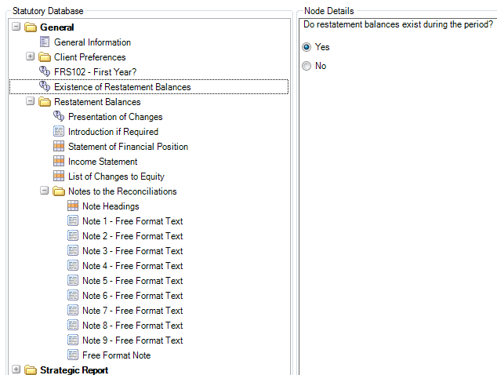

The grid nodes allow you to enter or view the following information:

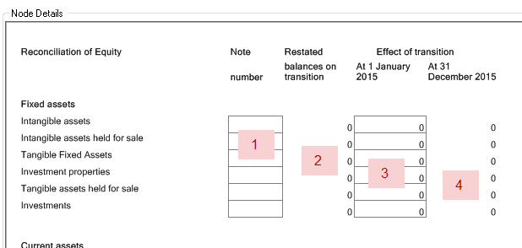

* 1. You can enter a free-text note number, for example "1"or "(i)"or "1, 2". This will be used to cross reference to further narrative to support the restatement amount.
* 2. This read-only column will automatically display the total value of the restatement journals entered for each row.
* 3. Here you must fill in the split of the total restatement that applies to the pre-comparative period.
* 4. This read-only column will automatically calculate the split of the total restatement that applies to the comparative period.

Note that the grid for the Income Statement only displays Columns 1 and 2.

Nine free text headings and paragraph nodes are also provided for you to input further narrative.

There are columns further to the right for entry of prior period adjustments made at the same time - see notes on page 17.

## 4. Reconcile the "Transition To FRS 102" Format

This format is found in the Full Accounts collection within the Financial Statements, and is Note96 at the bottom of the list.

The format displays the data entered in the Statutory Database and shows the effect of the transition adjustments on the major figures of the Balance Sheet and Income Statement.

Please check that you are satisfied with the detail disclosed on this format.

The format may be presented in either a summarised "list" view, or a more detailed "movements" view, by selecting the required option in the Statutory Database. (See page 17 above for more details).

## 5. Amend the Cash Flow Statement

Where an entity requires a cash flow, the transition effects within the current period will be picked up automatically and there are no adjustments required.

For the comparative period, the closing balances of the pre-comparative period will not reconcile to the restated opening balances. You can choose between the following methods for providing the correct cash flow figures for comparatives:

* Within the comparative year, you can enter a restatement journal for the transition adjustments relating to the opening balances of the comparative year. This will affect the pre-comparative balances as seen in the current year. You only need to make a summary journal. You will need to check that your journal agrees to the opening balance element shown in the transition grid analysis noted above.
* For simple transition adjustments, you might instead be able to make appropriate adjustments by using the cash flow roundings grid in the statutory database.
* Alternatively, you can amend the cash flow format manually.

## 6. Amend the Deferred Taxation analysis

The deferred taxation note analyses movements for the current and prior years between the causes of deferred taxation. Where there are restatement journals affecting deferred tax balances, these need to be reflected in the statutory database analysis. This is best explained by an example. In the following, there is a restatement of deferred tax relating to investment property, which would pass through profit and loss. The restatement journal was:

(3,000) Cr Deferred tax creditor (£2,000 opening balance, £1,000 closing)

1,000 Dr Deferred tax charge (affects prior year profit and loss)

2,000 Dr Retained profits (affects balance brought forward in prior year)

[Note that the current year TB would also need to reflect the total effect of this, i.e. deferred tax creditor Cr £3,000 and Retained profits Dr £3,000].

The following additional steps required are:

* Create a restatement journal in the prior year: £2,000 Cr Deferred tax, Dr Retained profit.
* In the pre-prior year (i.e. two years ago) open the statutory database grid for deferred tax movements and amend the closing balance line to show an additional £(2,000) creditor in the revaluation column. The grid will show that the balances are £2,000 "wrong" because that year cannot look forward to restatement journals made in the next year.
* In the prior year (i.e. one year ago) open the statutory database grid for deferred tax movements and (a) amend the movements in the revaluation column, with a £(1,000) credit in the Profit & loss charge row: (b) amend the closing balance to reflect the additional cumulative £(3,000) credit. The grid will show that the movements and closing balance are "wrong" by £3,000 because that year cannot look forward to restatement journals made in the next year, though it will include the restatement made for the pre-prior year.
* The current year deferred tax movements grid and corresponding deferred tax note should now be correct (assuming it was reconciled correctly before starting this exercise).
* The tax rate reconciliation will also need to be amended. This is found in the current year statutory database under profit and loss notes. There is a one-line entry required at the top of the current year column, affecting the prior year.

# Prior Period Errors

Errors in previous accounting treatment might be made at the same time as a transition to FRS 102, or might be made independently of transition adjustments. Both type of adjustments are made through restatement journals. The following sets out the procedure to be adopted.

### Adjustment of "prior period material errors" with no FRS 102 transition adjustment

In the following example, the current year end is 31/12/2015. A prior period adjustment needs to be made to accrued wages for the prior year.

1. Enter the adjustment to wages and the accrual as a restatement journal in the current year. Restatement journals only affect the prior year as seen in the financial statements of the current year.

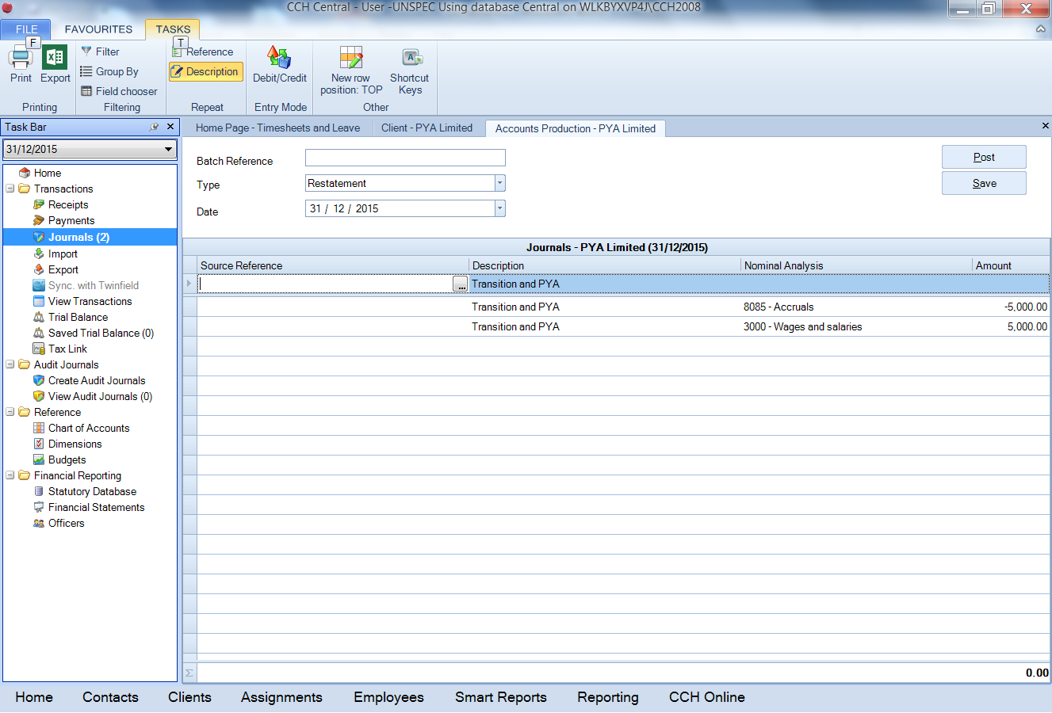

1. Enter the corresponding adjustment to the current year opening balances, using a standard journal. (Note that for master pack 8 only, the journal below should be made to code 5300 Prior year adjustment instead of 9900 Retained profit).

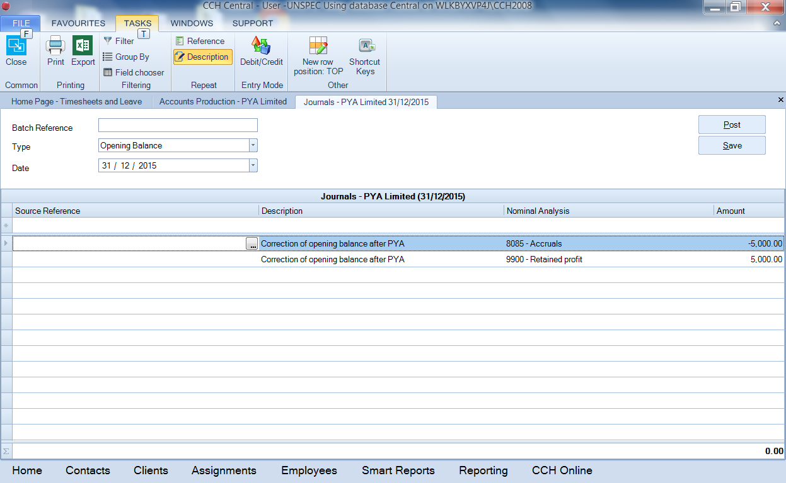

1. In the statutory database, confirm that a prior period adjustment exists (otherwise the system will assume that all the adjustments arise from transition).

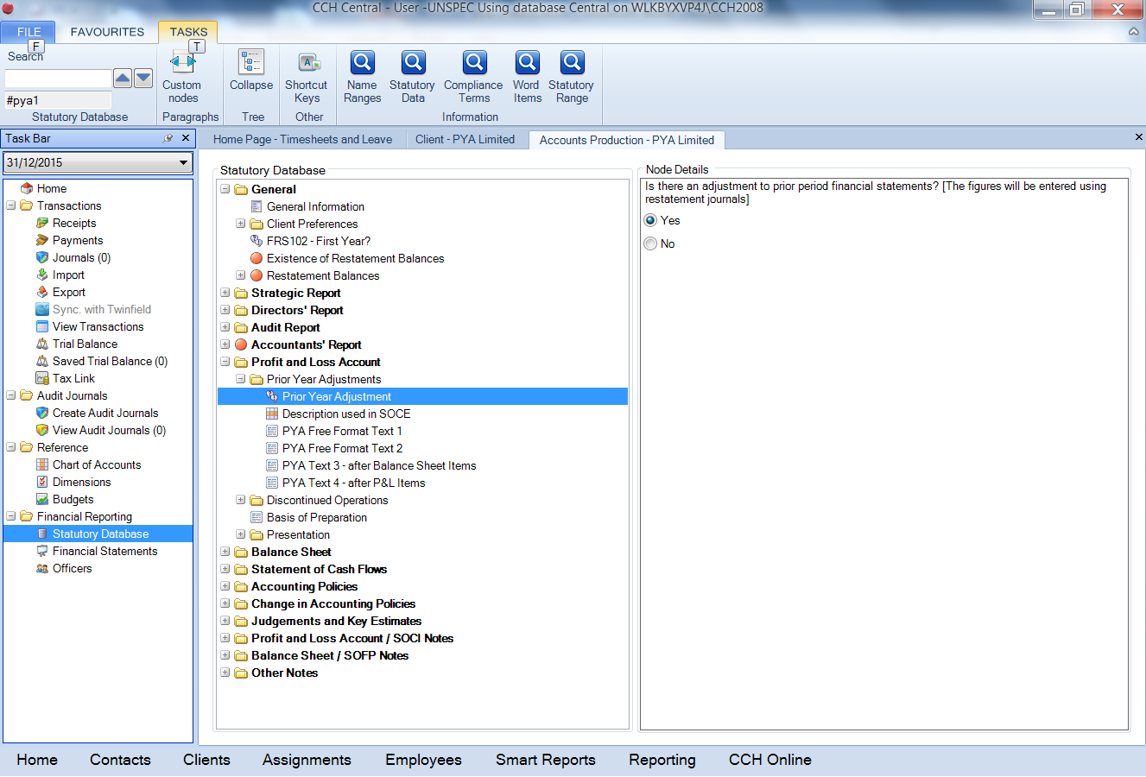

1. Check that the statement of changes in equity for error messages that will appear if there is a mismatch between prior year closing and current year opening figures. The note will now refer to figures "As restated".

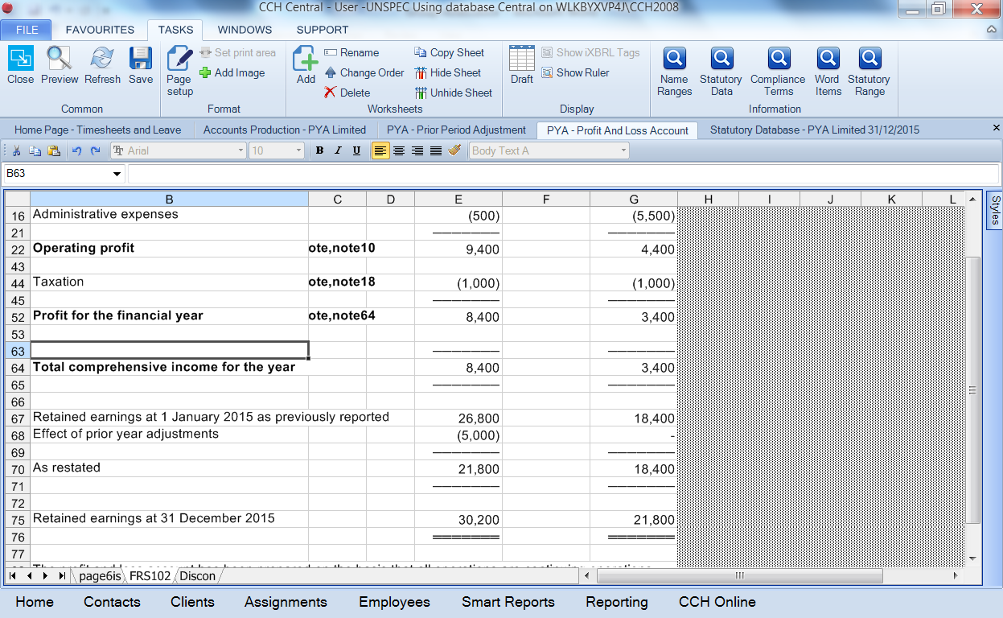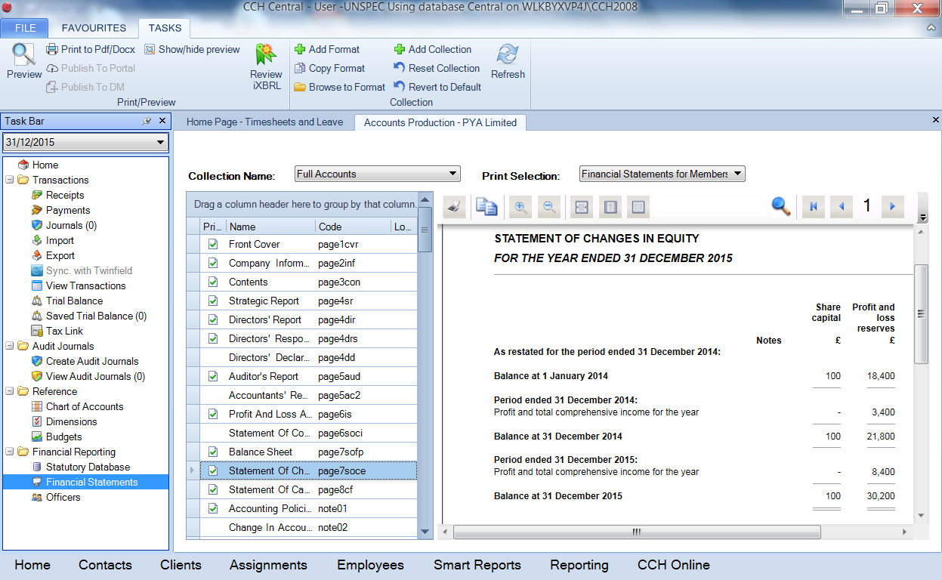If you have chosen (where permissible) to have a combined statement of income and retained equity, this should show the information instead, as follows.

1. Check the prior period adjustment note:

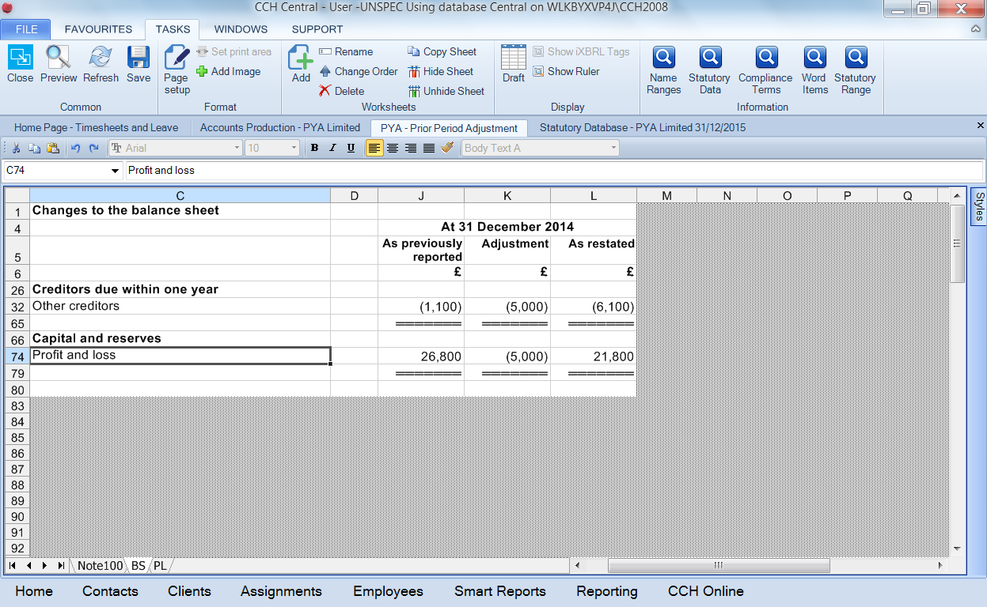

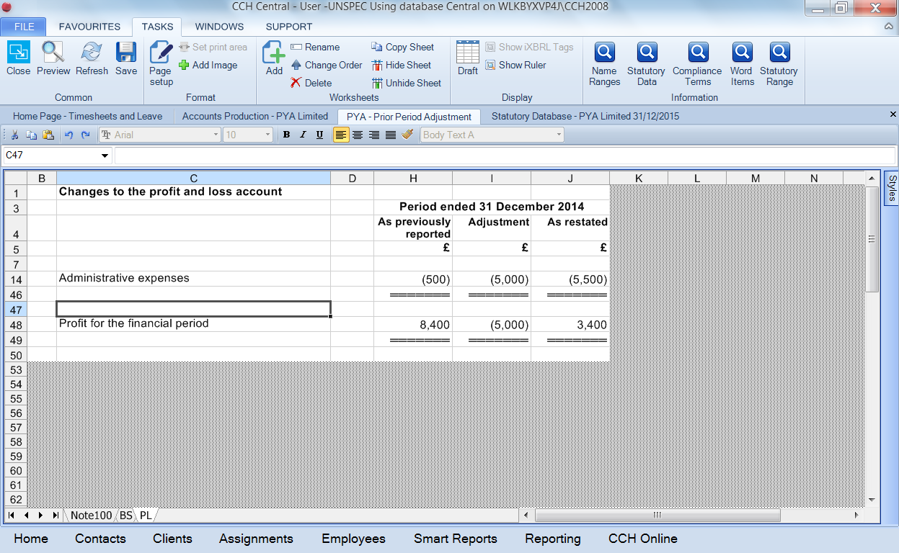

### Adjustment of "prior period material errors" together with a FRS 102 transition adjustment

In this example, the full adjustment is still £5,000 as before, but only £2,000 of that is a prior period adjustment and the remaining £3,000 is a transition adjustment. This is achieved in the software as follows.

1) Make the restatement journal adjustments as above, but then confirm also that FRS 102 restatement balances exist.

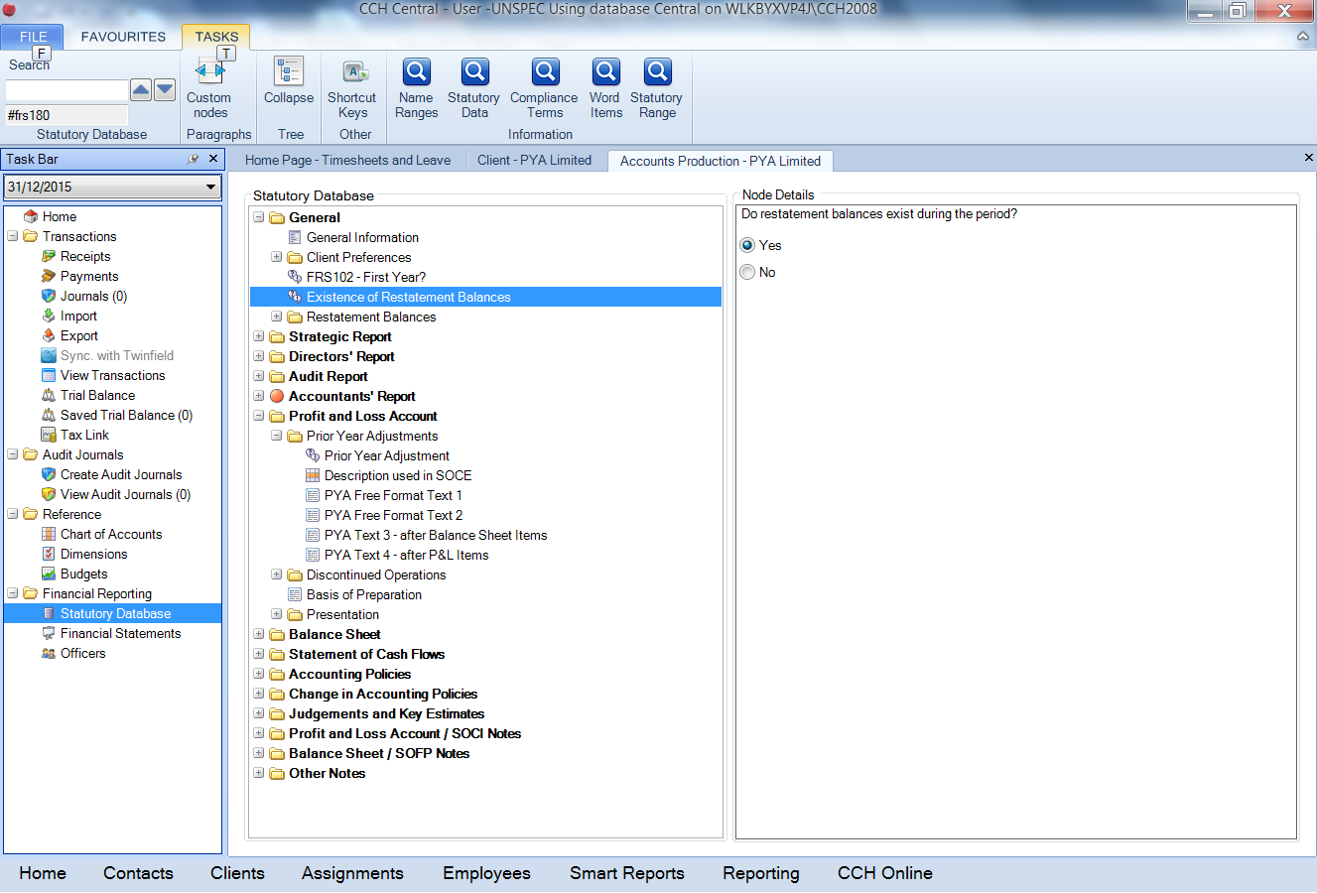

2) In the first transition grid, enter the PYA amounts in the columns set to the right of the transition adjustments. Before any entries are made, the software assumes that the full £5,000 is for transition. Once a prior period error adjustment is made (eg, £2,000 as below), the table is recalculated to allocate only the remaining £3,000 to transition. (Note that the PYA effect on the retained earnings figure has yet to be entered below, which is why there is a warning that £2,000 remains to be allocated.)

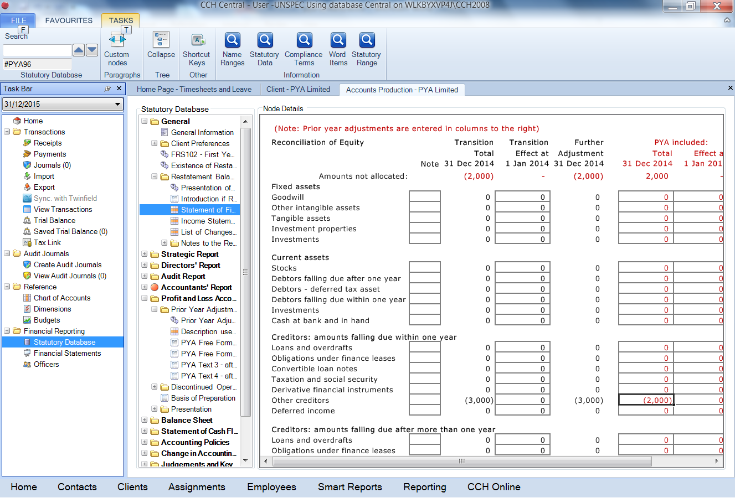3) Make the corresponding entry for the PYA element of the P&L charge.

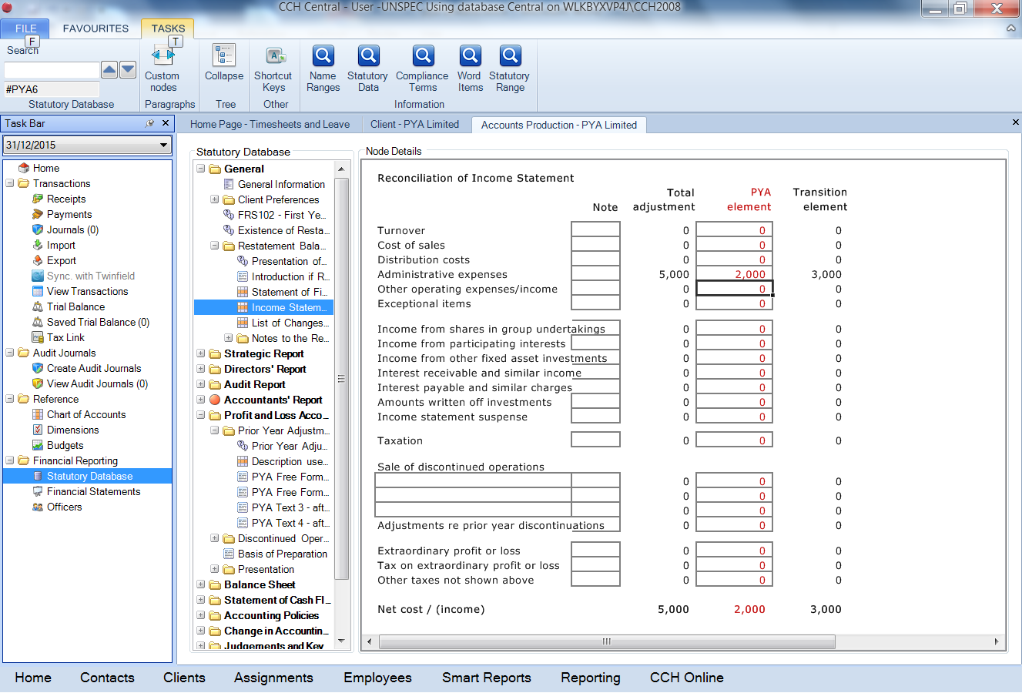

4) If the "List of changes" for transition is being used, the figures expected are automatically adjusted for PYA entries:

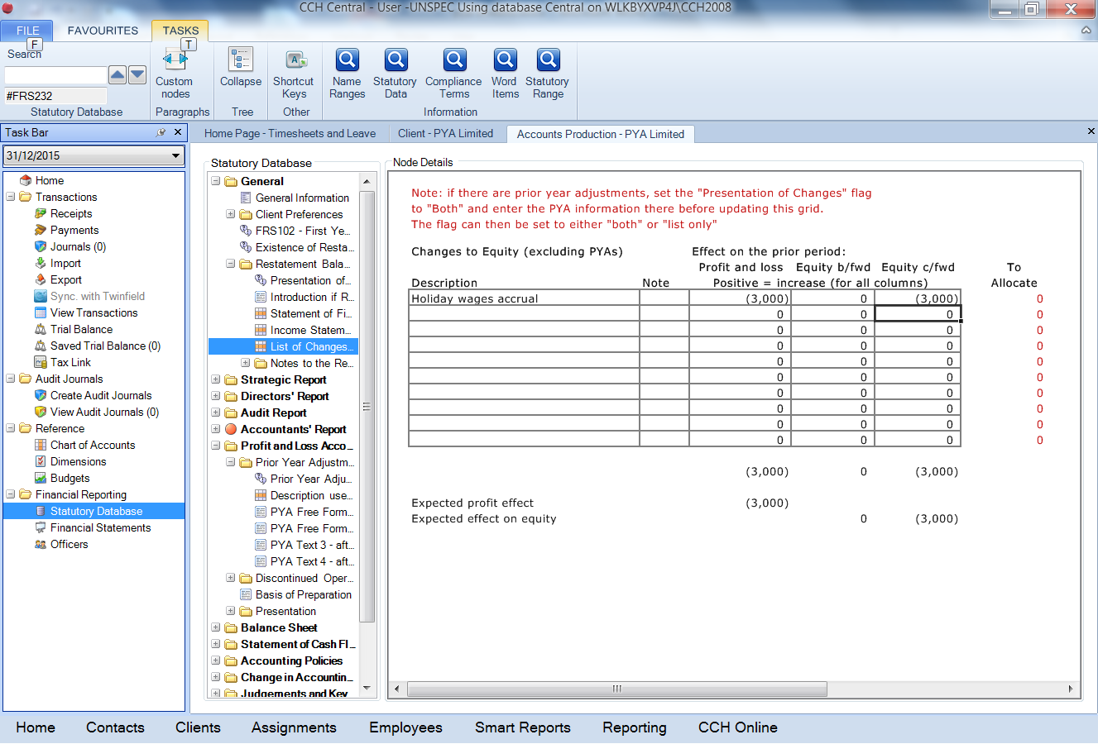

5) The Prior period error note is shown as before, with the revised figures (£2,000 instead of £5,000). The FRS 102 transition note is also displayed and shows the effect of the PYA:

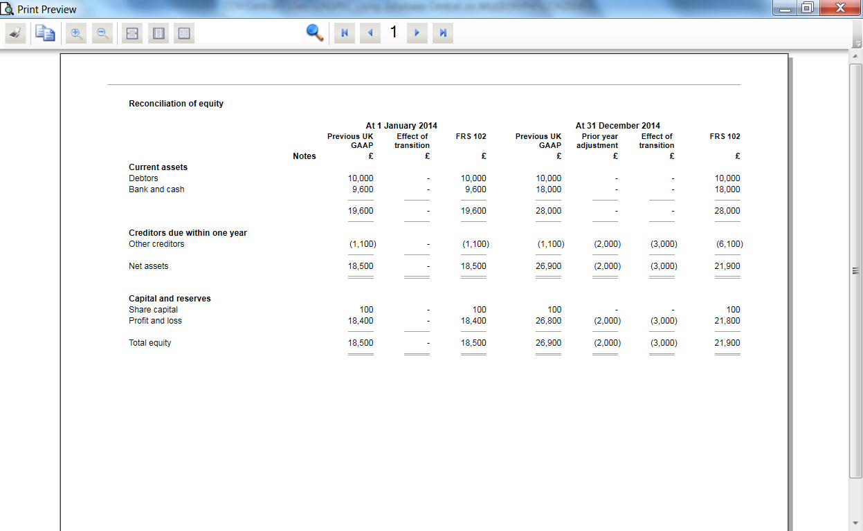

6) Where the prior period adjustments materially affect the prior year opening balances, these are entered in the grid set out in (2) above.

# Known Issues

# Appendix 1 - Format Guide

Detailed below is a list of the Master Pages and Notes for the CCH Limited (FRS 102) Master Pack (Full Collection):

|  |  |  |
| --- | --- | --- |
| Seq | Name | Code |
| 0 | Front Cover | Page1cvr |
| 1 | Company Information | Page2inf |
| 2 | Contents | Page3con |
| 3 | Strategic Report | Page4sr |
| 4 | Directors' Report | Page4dir |
| 5 | Directors' Responsibilities Statement | Page4drs |
| 6 | Directors' Declaration | Page4dd |
| 7 | Auditor's Report | Page5aud |
| 8 | Accountants' Report | Page5ac2 |
| 9 | Profit And Loss Account | Page6is |
| 10 | Statement of Comprehensive Income | Page6soci |
| 11 | Balance Sheet | Page7sofp |
| 12 | Statement of Changes in Equity | Page7soce |
| 13 | Statement of Cash Flows | Page8cf |
| 14 | Accounting Policies | Note01 |
| 15 | Change in Accounting Policies | Note02 |
| 16 | Critical Accounting Estimates | Note03 |
| 17 | Spare Note 1 | Note04 |
| 18 | Turnover | Note05 |
| 19 | Exceptional Items | Note06 |
| 20 | Spare Note 2 | Note07 |
| 21 | Spare Note 3 | Note08 |
| 22 | Spare Note 4 | Note09 |
| 23 | Operating Profit | Note10 |
| 24 | Auditors' Remuneration | Note11 |
| 25 | Employees | Note12 |
| 26 | Directors' Remuneration | Note82 |
| 27 | Spare Note 5 | Note13 |
| 28 | Investment Income | Note14 |
| 29 | Interest Payable and Similar Charges | Note15 |
| 30 | Other Gains And Losses | Note16 |
| 31 | Insurance (CLG) | Note101 |
| 32 | Fire Safety (CLG) | Note102 |
| 33 | Spare Note 6 | Note17 |
| 34 | Taxation | Note18 |
| 35 | Discontinued Operations | Note19 |
| 36 | Spare Note 7 | Note20 |
| 37 | Dividends | Note21 |
| 38 | Impairments | Note23 |
| 39 | Spare Note 8 | Note24 |
| 40 | Intangible Assets | Note25 |
| 41 | Tangible Assets | Note26 |
| 42 | Investment Property | Note27 |
| 43 | Fixed Asset Investments | Note28 |
| 44 | Spare Note 9 | Note29 |
| 45 | Financial Instruments | Note30 |
| 46 | Stocks | Note31 |
| 47 | Construction Contracts | Note32 |
| 48 | Financial Lease Receivables | Note33 |
| 49 | Debtors | Note34 |
| 50 | Current Asset Investments | Note35 |
| 51 | Assets & Liabilities Classified as Held for Sale | Note36 |
| 52 | Borrowings | Note39 |
| 53 | Spare Note 10 | Note37 |
| 54 | Creditors Due Within One Year | Note43 |
| 55 | Spare Note 11 | Note38 |
| 56 | Creditors Due After One Year | Note46 |
| 57 | Finance Lease Obligations | Note41 |
| 58 | Convertible Loan Note | Note42 |
| 59 | Other Creditors Due Within One Year | Note108 |
| 60 | Spare Note 12 | Note44 |
| 61 | Other Creditors Due After One Year | Note109 |
| 62 | Spare Note 13 | Note45 |
| 63 | Provisions For Liabilities | Note48 |
| 64 | Spare Note 14 | Note49 |
| 65 | Deferred Taxation | Note50 |
| 66 | Grants And Deferred Income | Note51 |
| 67 | Spare Note 15 | Note52 |
| 68 | Retirement Benefit Schemes | Note53 |
| 69 | Share-Based Payment Transactions | Note54 |
| 70 | Share Capital | Note55 |
| 71 | Members Liability (CLG) | Note103 |
| 72 | Share Premium Account | Note56 |
| 73 | Revaluation Reserve | Note57 |
| 74 | Other Reserves | Note58 |
| 75 | Equity Reserves | Note59 |
| 76 | Capital Redemption Reserve | Note60 |
| 77 | Hedging and Translation Reserve | Note61 |
| 78 | Spare Note 16 | Note62 |
| 79 | Spare Note 17 | Note63 |
| 80 | Retained Earnings | Note64 |
| 81 | Audit Report Information | Note99 |
| 82 | Acquisitions | Note65 |
| 83 | Disposals | Note66 |
| 84 | Spare Note 18 | Note67 |
| 85 | Financial Commitments, Guarantees And Contingent Liabilities | Note68 |
| 86 | Operating Lease Commitments | Note69 |
| 87 | Capital Commitments | Note70 |
| 88 | Spare Note 19 | Note72 |
| 89 | Events After the Reporting Date | Note73 |
| 90 | Related Party Transactions | Note74 |
| 91 | Directors' Interests | Note97 |
| 92 | Directors' Transactions | Note75 |
| 93 | Controlling Party | Note76 |
| 94 | Common Areas (CLG) | Note104 |
| 95 | Planned Expenditure (CLG) | Note105 |
| 96 | Spare Note 20 | Note77 |
| 97 | Subsidiaries | Note78 |
| 98 | Associates | Note79 |
| 99 | Joint Ventures | Note80 |
| 100 | Spare Note 21 | Note81 |
| 101 | Significant Undertakings | Note106 |
| 102 | Spare Note 22 | Note83 |
| 103 | Spare Note 23 | Note84 |
| 104 | Cash Generated From Operations | Note85 |
| 105 | Spare Note 24 | Note90 |
| 106 | Spare Note 25 | Note91 |
| 107 | Spare Note 26 | Note92 |
| 108 | Off Balance Sheet Arrangements | Note94 |
| 109 | Auditor's Liability Limitation Agreement | Note93 |
| 110 | Transition To FRS 102 | Note96 |
| 111  112 | Prior Period Adjustment  Approval of Financial Statements | Note100  Note107 |

# Appendix 2 - Adoption of the FRS102 standards by an existing UKGAAP job

Over the coming months, the majority of your existing jobs in CCH Accounts Production will need to adopt the new FRS102 standards, or related SORPs. The new FRS102 standards are contained in a new master pack. Normally an existing job cannot 'switch' from one master pack to another, but to facilitate the adoption of FRS102, the application includes a set of adoption tools to allow this process.

Follow the simple steps below to accomplish this process efficiently, with a minimum of data setup or re-keying.

Overview of the adoption process:

1) Year End the job and confirm you wish to adopt FRS102 (or IFRS)

2) Map any additional nominal codes required to convert the Trial Balance to the new FRS102 or IFRS chart of accounts, which are not included in the default nominal mapping provided

At this point you will have created the new accounting period using the FRS102 or IFRS master pack.

3) Verify that the Trial Balance is correct

4) Verify any Saved Trial Balances or Budgets have been converted correctly

5) Verify that the Statutory Database values have been converted correctly. (Not all Statutory Database values are converted, only those that remain valid under the new accounting framework will be converted)

At this point you can now continue to process the first year of FRS102 or IFRS accounts.

6) Enter any restatement journals required to restate balances resulting from the transition to the new FRS102 or IFRS standards.

Step by Step detailed instructions:

1) Year End the UKGAAP job

When you run the year end routine, there will be a new option to adopt FRS102 or IFRS:

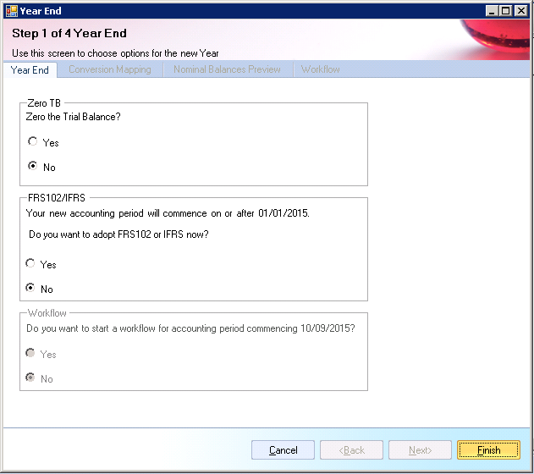

The default selection is "No", in which case the new accounting period will continue to use the same master pack as the existing period did.

If you select "Yes", the Year End will result in the new accounting period using the new FRS102 or IFRS master pack.

The legislation permits the early adoption of FRS102. Therefore if the new accounting period commences prior to 01/01/2015, a different question is displayed:

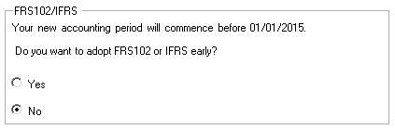

In either case, if you select "Yes", then you can click Next to move to the next step in the Year End Wizard.

2) Conversion Mapping

Step 2 of the Wizard presents you with the default entity mappings used in the adoption of FRS102 or IFRS:

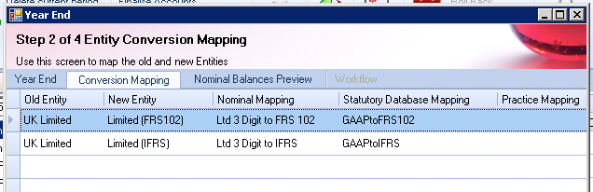

(Hint - If you are not licenced for the IFRS Master Pack, you will not see the IFRS option in the screen shot above).

Old Entity - this is the current entity of the accounting period being year ended

New Entity - this is the new entity that the new accounting period will use

Nominal Mapping - this shows the default Nominal Mapping that will be used to convert the Trial Balance data

Practice Mapping - this shows an icon if the option was added by the Administrator rather than being provided by CCH

The user must select the row that they wish to use before clicking Next.

Note - you must have at least one published version of the FRS102 or IFRS master pack. If you do not, the Year End Wizard will stop and display the following message:

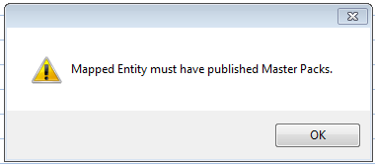

Please close the year end wizard and publish the FRS102 master pack in question via Maintenance > Accounts > Master Pack Publish.

Hint - the administrator can create or edit these settings via a new Maintenance screen. File > Maintenance > Accounts > Master Pack Conversion. See "Advanced Settings" below for more details.

3) Nominal Balances Preview

Step 3 is to convert existing nominal code balances to the new FRS102 or IFRS Chart of Accounts. This requires the use of a nominal mapping, which was selected in the previous Wizard step.

The current Trial Balance for the period being year ended is shown, (both Current and Comparative if present):

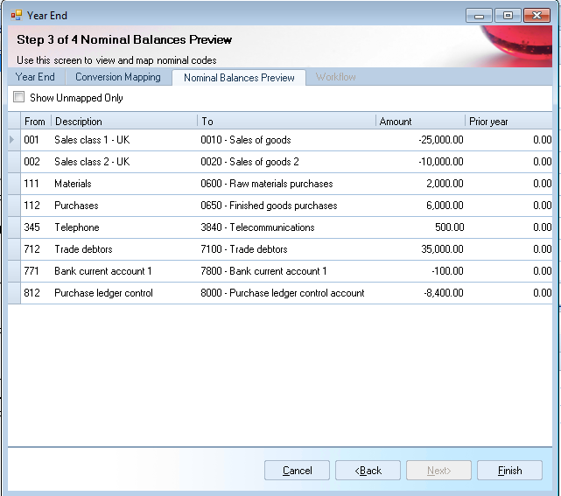

Hint - this screen is the same one as you are already familiar with from the existing "Import" routine within CCH Accounts Production.

The "From" and "Description" columns show the nominal codes and descriptions for the period being year ended.

The "To" column shows the Nominal code from the new FRS102 or IFRS Chart of Accounts that has been mapped to.

Just like when you import Transactions or Trial Balance from a csv file, if any nominal codes are unmapped, you must select or create a nominal before you can continue.

* You can tick "Show Unmapped Only" to filter the list to only display any unmapped codes.
* You can press F10 to create new nominal codes within the FRS102 or IFRS Chart if required.

Once all nominal codes have been mapped, press Finish to complete the Year End process.

If you have amended any nominal code mappings, the application will prompt you to save the changes you have made. Once saved, this nominal mapping can be used for future conversions or imports.

CCH Accounts Production will now create a new accounting period using the new FRS102 or IFRS master pack.

In addition, further comparative and pre-comparative accounting periods are also created, to store the restatement transactions in. These are both set as "Comparative Only" periods as they exist solely to hold comparative data. By default they will be hidden, but you may view them by unticking "Hide Comparative Only periods" if you wish.

View of Accounts Production tab prior to adopting FRS102, showing 4 UKGAAP periods:

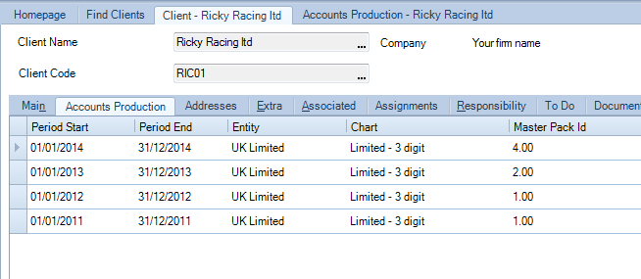

View of Accounts Production tab after adopting FRS102, showing the 4 original UKGAAP accounting periods plus the new FRS102 accounting period:

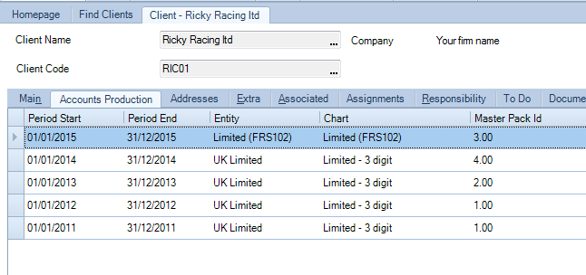

During the adoption of FRS102 or IFRS, three other actions are occurring behind the scenes:

1) Conversion of any Saved Trial Balances

2) Conversion of any Budgets

3) Conversion of certain Statutory Database values

Saved Trial Balances and Budgets

If the accounting periods have any Saved Trial Balances or Budgets set up, these will use the same Nominal Mapping as used above to convert themselves into the new FRS102 or IFRS accounting period. This means that they can continue to be referenced in formats if required.

Statutory Database values

Not all the data set up in the UKGAAP Statutory Database is relevant or required under the new FRS102 or IFRS standards. Therefore only a subset of the information from the Statutory Database is converted into the new FRS102 or IFRS accounting period. Up to 163 values are converted, for example:

* Principal Activities paragraph
* Fixed Asset headings
* Company Registration Number
* Number of Employees

Appendix 2 below contains a list of all the values from the Statutory Database that will be converted if present.

Advanced Settings

1. Setting up additional FRS102 adoption options.

You may wish to define alternative FRS102 adoption options. For example if you have Cloned Entities that you wish to be able to convert during the year end to a different master pack (either a new Cloned Entity or back to a CCH master pack), or if you have an alternative Chart of Accounts within a CCH master pack.

This can be done via File > Maintenance > Accounts > Master Pack Conversion:

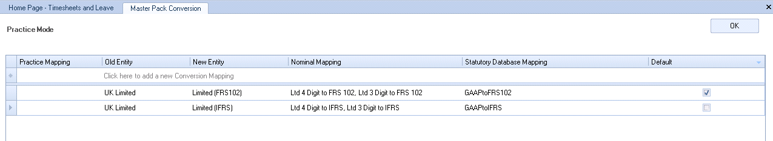

On this screen you can add new conversion options, which will appear on the second step of the Year End Wizard for the relevant accounting periods.

(Hint - If you are not licenced for the IFRS Master Pack, you will not see the IFRS option in the screen shot above).

Practice Mapping - this will display an icon for any new rows you add.

Old Entity - select from the drop down list the Entity that you will be Year Ending.

New Entity - select from the drop down list the Entities that you wish to have the option to convert into.

Nominal Mapping - select from a drop down list of available Nominal Mappings in the system. (These are created/maintenance via File > Maintenance > Accounts > Import/Export Definition > Nominals Mapping). You can select more than one Nominal Mapping if required (for example 3 and 4 digit options).

Statutory Database Mapping - this is a new Mapping which controls which Statutory Database values will be converted into the new accounting period as part of the Year End.

Default - In the case where one "Old Entity" is being mapped to more than one "New Entity", you can indicate which option is the default. The Default option will be pre-selected during step 2 of the Year End Wizard.

2. How to re-adopt FRS102 or IFRS.

If you ever need to go back to the original UKGAAP job and re-adopt FRS102 or IFRS, it is possible as follows:

1) First, you must delete the existing FRS102 or IFRS accounting periods. From the Client screen, select the Accounts Production tab. Untick the "Hide Comparative Only periods" option at the bottom of the screen. You should see 3 periods that use the FRS102 master pack or IFRS.

2) Open the most recent of these three periods.

3) Click "Delete Current Period".

4) Repeat step 3) twice more to delete all three of the FRS102 or IFRS periods.

5) You can now load the latest UKGAAP period, and run through the Year End routine again.

Limitations of the FRS102 or IFRS conversion

1. Dimensions

If the job you are converting has Dimensions set up, these will need to be created again in the new accounting period in FRS102 or IFRS.

2. Five Year Summary report

The Five Year Summary report will only be able to display 3 years of data, due to the inability to combine balances from the old nominal chart alongside balances from the new FRS102 or IFRS chart.

# Appendix 3 - List of Statutory Database items converted to FRS102 for UK Limited companies

|  |  |
| --- | --- |
| #CD34 | Principal Activities |
| #CD46 | Fair Review of the Business |
| #CD229 | Description of Principal Risks and Uncertainties |
| #CD230 | The Position of the Company at the Year End |
| #CD231 | Analysis based on Key Performance Indicators |
| #CD33 | Ordinary |
| #CD157 | Preference |
| #CD47 | Market Value of Land and Buildings |
| #CD48 | Research and Development |
| #CD36 | Post Balance Sheet Events |
| #CD35 | Future Developments |
| #CD201 | Purchase of own shares |
| #CD158 | Retirements |
| #CD4 | Changes in Presentation to the Financial Statements |
| #CD5 | Directors' Insurance |
| #CD41 | Re-appointment |
| #CD42 | Appointment in year |
| #DT2 | Treasury operations and Financial instruments - Title |
| #DT3 | Treasury operations and Financial instruments - Free format text |
| #DT4 | Liquidity risk -Title |
| #DT5 | Liquidity risk - Free format text |
| #DT6 | Interest rate risk - Title |
| #DT7 | Interest rate risk - Free format text |
| #DT8 | Foreign currency risk -Title |
| #DT9 | Foreign currency risk - Free format text |
| #DT10 | Credit risk - Title |
| #DT11 | Credit risk - Free format text |
| #DT12 | Spare - Title |
| #DT13 | Spare - Free format text |
| #DT14 | Title |
| #DT15 | Paragraph |
| #DT16 | Title |
| #DT17 | Paragraph |
| #CD44 | Date of signing of Directors' Report |
| #AR8 | Qualified Audit report type |
| #CD19 | Description (nature of uncertainty/other matters) |
| #CD233 | Senior statutory auditor exemption |
| #CD58 | Date of signing Audit Report |
| #CD58 | Date of signing Accountant's Report |
| #AR10 | CCAB Accounts Preparation Report? |
| #CD210 | Date of engagement letter |
| #CD217 | Accountants' designation |
| #CD135 | Fundamental Uncertainty |
| #CD58 | Date of signing Accountant's Report |
| #CD74 | Depreciation rate - Land and buildings |
| #CD75 | Depreciation rate - Leasehold properties |
| #CD76 | Depreciation rate - Plant and machinery |
| #CD198 | Depreciation rate - Computer equipment |
| #CD77 | Depreciation rate - Fixtures, fittings and equipment |
| #CD78 | Depreciation rate - Motor vehicles |
| #CD199 | Depreciation rate - Other assets |
| #CD79 | Depreciation - No depreciation |
| #CD153 | Defined benefit scheme |
| #CD150 | Title |
| #CD151 | Paragraph |
| #CD170 | Title |
| #CD171 | Paragraph |
| #CD172 | Title |
| #CD173 | Paragraph |
| #PN2 | Turnover by geographical area |
| #PN3 | Turnover by geographical area |
| #PN4 | Turnover by geographical area |
| #PN5 | Turnover by geographical area |
| #PN6 | Turnover by geographical area |
| #PN191 | Turnover by geographical area |
| #PN192 | Turnover by geographical area |
| #PN193 | Turnover by geographical area |
| #PN194 | Turnover by geographical area |
| #PN195 | Turnover by geographical area |
| #PN196 | Turnover by geographical area |
| #PN197 | Turnover by geographical area |
| #PN198 | Turnover by geographical area |
| #PN199 | Turnover by geographical area |
| #PN200 | Turnover by geographical area |
| #PN201 | Turnover by geographical area |
| #PN202 | Turnover by geographical area |
| #PN203 | Turnover by geographical area |
| #PN204 | Turnover by geographical area |
| #PN205 | Turnover by geographical area |
| #PN2 | Turnover by geographical area |
| #PN3 | Turnover by geographical area |
| #PN4 | Turnover by geographical area |
| #PN5 | Turnover by geographical area |
| #PN6 | Turnover by geographical area |
| #PN191 | Turnover by geographical area |
| #PN192 | Turnover by geographical area |
| #PN193 | Turnover by geographical area |
| #PN194 | Turnover by geographical area |
| #PN195 | Turnover by geographical area |
| #PN196 | Turnover by geographical area |
| #PN197 | Turnover by geographical area |
| #PN198 | Turnover by geographical area |
| #PN199 | Turnover by geographical area |
| #PN200 | Turnover by geographical area |
| #PN201 | Turnover by geographical area |
| #PN202 | Turnover by geographical area |
| #PN203 | Turnover by geographical area |
| #PN204 | Turnover by geographical area |
| #PN205 | Turnover by geographical area |
| #PN2 | Profit before tax by geographical area |
| #PN3 | Profit before tax by geographical area |
| #PN4 | Profit before tax by geographical area |
| #PN5 | Profit before tax by geographical area |
| #PN6 | Profit before tax by geographical area |
| #PN191 | Profit before tax by geographical area |
| #PN192 | Profit before tax by geographical area |
| #PN193 | Profit before tax by geographical area |
| #PN194 | Profit before tax by geographical area |
| #PN195 | Profit before tax by geographical area |
| #PN2 | Profit before tax by geographical area |
| #PN3 | Profit before tax by geographical area |
| #PN4 | Profit before tax by geographical area |
| #PN5 | Profit before tax by geographical area |
| #PN6 | Profit before tax by geographical area |
| #PN191 | Profit before tax by geographical area |
| #PN192 | Profit before tax by geographical area |
| #PN193 | Profit before tax by geographical area |
| #PN194 | Profit before tax by geographical area |
| #PN195 | Profit before tax by geographical area |
| #PN2 | Net assets by geographical area |
| #PN3 | Net assets by geographical area |
| #PN4 | Net assets by geographical area |
| #PN5 | Net assets by geographical area |
| #PN6 | Net assets by geographical area |
| #PN191 | Net assets by geographical area |
| #PN192 | Net assets by geographical area |
| #PN193 | Net assets by geographical area |
| #PN194 | Net assets by geographical area |
| #PN195 | Net assets by geographical area |
| #PN2 | Net assets by geographical area |
| #PN3 | Net assets by geographical area |
| #PN4 | Net assets by geographical area |
| #PN5 | Net assets by geographical area |
| #PN6 | Net assets by geographical area |
| #PN191 | Net assets by geographical area |
| #PN192 | Net assets by geographical area |
| #PN193 | Net assets by geographical area |
| #PN194 | Net assets by geographical area |
| #PN195 | Net assets by geographical area |
| #BN2 | Asset type headings |
| #BN3 | Asset type headings |
| #BN4 | Asset type headings |
| #BN6 | Asset type headings |
| #BN7 | Asset type headings |
| #BN8 | Asset type headings |
| #BN9 | Asset type headings |
| #BN10 | Asset type headings |
| #BN166 | Asset type headings |
| #BN167 | Asset type headings |
| #BN11 | Revaluation of land and buildings |
| #BN12 | Comparable historic cost for land and buildings at valuation |
| #BN13 | Comparable historic cost for land and buildings at valuation |
| #BN14 | Comparable historic cost for land and buildings at valuation |
| #BN15 | Comparable historic cost for land and buildings at valuation |
| #BX55 | Comparable historic cost for land and buildings at valuation |
| #BX57 | Comparable historic cost for land and buildings at valuation |
| #BN22 | Net book value and depreciation of leased assets |
| #BN23 | Net book value and depreciation of leased assets |
| #BN24 | Net book value and depreciation of leased assets |
| #BN25 | Net book value and depreciation of leased assets |
| #BN26 | Net book value and depreciation of leased assets |
| #BN27 | Net book value and depreciation of leased assets |
| #BN144 | Share premium account |
| #BN145 | Revaluation reserve |
| #BN165 | Other reserves |
| #BN146 | Profit and loss account |
| #CD69 | Date of signing of Balance Sheet |
| #ON2 | Contingent Liabilities |
| #ON16 | Commitments at Year End |
| #ON17 | Commitments at Year End |
| #ON21 | Benefits in kind |
| #ON92 | Directors' retirement benefits |
| #ON94 | Directors' retirement benefits |
| #ON96 | Directors' share options |
| #ON98 | Directors' long term incentive schemes |
| #ON100 | Directors' long term incentive schemes |
| #ON27 | Highest paid director- remuneration and retirement benefits |
| #ON102 | Highest paid director- remuneration and retirement benefits |
| #ON104 | Highest paid director- remuneration and retirement benefits |
| #ON106 | Highest paid director- remuneration and retirement benefits |
| #ON108 | Highest paid director- remuneration and retirement benefits |
| #ON27 | Highest paid director- remuneration and retirement benefits |
| #ON110 | Highest paid director - share options |
| #ON111 | Highest paid director - shares under incentive scheme |
| #ON29 | Directors' remuneration waived |
| #ON52 | Number of employees |
| #ON53 | Number of employees |
| #ON54 | Number of employees |
| #ON55 | Number of employees |
| #ON56 | Number of employees |
| #ON57 | Number of employees |
| #ON58 | Number of employees |
| #ON59 | Number of employees |
| #ON60 | Number of employees |
| #ON61 | Number of employees |
| #ON69 | Number of employees |
| #ON70 | Number of employees |
| #ON71 | Number of employees |
| #ON72 | Number of employees |
| #ON73 | Number of employees |
| #ON74 | Number of employees |
| #ON75 | Number of employees |
| #ON76 | Number of employees |
| #ON77 | Number of employees |
| #ON78 | Number of employees |
| #ON68 | Post balance sheet events |
| #ON120 | Auditor liability limitation agreement |
| #CD2 | General Information |
| #CD3 | General Information |
| #CD14 | General Information |
| #CD26 | General Information |
| #CD59 | General Information |
| #CD63 | General Information |
| #CD205 | General Information |
| #CD218 | General Information |
| #CD46 | Fair Review of the Business |
| #CD229 | Description of Principal Risks and Uncertainties |
| #CD230 | Analysis of Development and Performance |
| #CD231 | Analysis based on Key Performance Indicators |
| #sr2 | Analysis using Other Key Performance Indicators |
| #sr3 | Additional Information and Explanations |
| #CD34 | Principal Activities |
| #CD46 | Fair Review of the Business |
| #CD229 | Description of Principal Risks and Uncertainties |
| #CD230 | The Position of the Company at the Year End |
| #CD231 | Analysis based on Key Performance Indicators |
| #CD201 | Purchase of own shares |
| #CD4 | Changes in Presentation to the Financial Statements |
| #CD5 | Directors' Insurance |
| #CD44 | Date of signing of Directors' Report |
| #AR8 | Qualified Audit report type |
| #CD19 | Description (nature of uncertainty/other matters) |
| #CD233 | Senior statutory auditor exemption |
| #CD58 | Date of signing Audit Report |
| #BN12 | Comparable historic cost for land and buildings at valuation |
| #BN13 | Comparable historic cost for land and buildings at valuation |
| #BN14 | Comparable historic cost for land and buildings at valuation |
| #BN15 | Comparable historic cost for land and buildings at valuation |
| #BX55 | Comparable historic cost for land and buildings at valuation |
| #BX57 | Comparable historic cost for land and buildings at valuation |

# Appendix 4 - FRS 102 Reporting Options

## Explanation of the Small Companies Exemptions, Abridged Accounts and Reduced Filing Copy.

The following 4 options are supported in CCH Accounts Production 2015.3 and above:

#### 1) Small Companies exemptions

Background

In July 2015 The Financial Reporting Council (FRC) issued a suite of changes which updated and, in many cases simplified, UK and Ireland accounting standards. Key amongst the changes are new requirements small entities and the withdrawal of the Financial Reporting Standard for Smaller Entities (FRSSE).

The changes are largely in response to the implementation of the new EU Accounting Directive, and include:

* a new standard, FRS 105 The Financial Reporting Standard applicable to the Micro-entities Regime:
* new Section 1A Small Entities of FRS 102 The Financial Reporting Standard applicable in the UK and Republic of Ireland: and
* other changes necessary for continued compliance with company law.

At the time of the release of CCH Accounts Production 2015.3 no model accounts were available and the implementation of the legislation in CCH Accounts Production is an initial release which is likely to be updated and adapted in later versions of the software.

The legislation clearly states that the accounts shall give a true and fair view and to this end the software allows the inclusion and exclusion of areas of the accounts. If a user wishes to include or exclude particular notes they can achieve this through the right-click Include or Exclude options in the Financial Statements screen.

#### Adoption in CCH Accounts Production Limited (FRS102) entity

To adopt Small Companies Exemptions in an FRS 102 master pack you must access General>Client Preferences within the Statutory Database and then select the Yes to Implementation of FRS 102 – Small Companies Exemption. Once the radio button is set to Yes, the Small Companies Exemptions folder containing related options will become active.

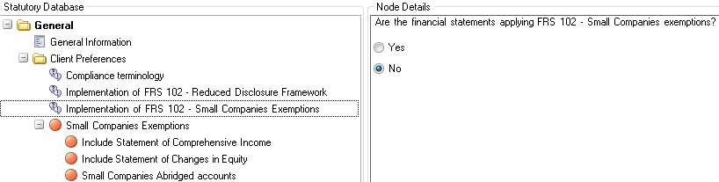

Selecting Small Companies Exemptions will by default exclude the Statement of Comprehensive Income, Statement of Changes in Equity, the Strategic Report and the Cash Flow Statement.

There are options within the Small Companies Exemptions folder to allow the user to override this exclusion and include the Statement of Comprehensive Income and/or the Statement of Changes in Equity. The existing option to Include Cash Flow, which also sits in Client Preferences, will have the effect of overriding the Small Companies Exemption and hence allow inclusion of a Cash Flow statement.

The Small Companies Exemptions allow for less disclosure in the Directors’ Report so the FRS 102 Master Pack will remove the default paragraphs from certain Statutory Database nodes (e.g. Disabled Persons) and the icon in the Statutory Database will appear Blue to indicate it is an optional disclosure. A user may still select a paragraph from the drop down or edit the blank paragraph to disclose if they wish.

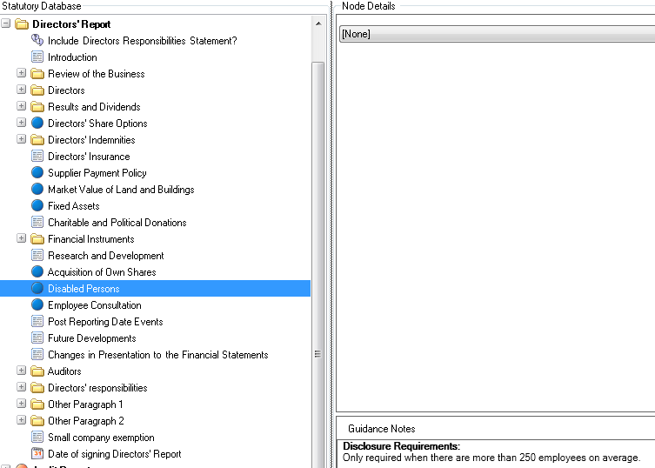

The Principal Activities node in the Statutory Database will also change to blue as the statement is no longer mandatory, however the user will need to remove any text from the paragraph to prevent it from appearing in the accounts. A statement has been added to the Directors’ Report advising that the report has been prepared in accordance with the special provisions relating to small companies within Part 15 of the Companies Act 2006.

Adopting Small Company exemptions will also trigger reduced disclosure in the notes to the accounts. The following notes are amended:

* Profit for the year note
* Employees note
* Intangible Fixed asset note
* Tangible fixed asset note
* Fixed asset investments note
* Debtors note
* Creditors note
* Borrowings note

CCH Accounts Production allows a user to easily override the reduced disclosure and instead output the full note for Tangible fixed assets, Intangible fixed assets, Debtors and Creditors, by selecting the relevant option within the Statutory Database. For example:

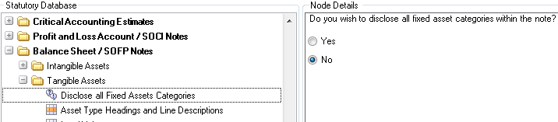

The following notes will be suppressed under the Small Companies Exemptions option:

* Directors’ Remuneration (UK only, will still be included for Ireland)
* Other gains and losses
* Taxation
* Dividends
* Stocks
* Finance lease receivables
* Convertible loan notes (UK only, will still be included for Ireland)
* Deferred taxation
* Retirement Benefit schemes

To override a user can right click on the format in Financial Statements and choose to Include.

Other changes include updates to the Accounting Policies (note that there are no reductions in disclosure), Contingent Liabilities note edited to include Financial Commitments and Guarantees, and the addition of a new note for Off Balance Sheet Arrangements.

#### 2) Small Companies Regulations Abridged Accounts (UK only)

FRS 102 1A states that a small company shall present a statement of financial position, and its profit or loss for a period in an income statement, in accordance with the requirements set out in Part 1 General Rules and Formats of Schedule 1 to the Small Companies Regulations (as updated by The Companies, Partnerships and Groups (Accounts and Reports) Regulations 2015).

This allows the preparers to either present the Profit and Loss accounts and Balance Sheet as per full FRS 102, draw up abridged versions or to adapt them.

CCH Accounts Production provides an option in the Small Companies Exemption folder within the Statutory Database to prepare Abridged accounts.

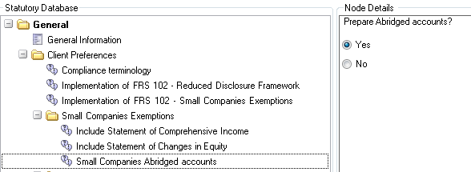

Setting Abridged accounts to Yes will result in the financial statements including an abridged Profit and Loss Account, an abridged Balance Sheet and further reduced disclosure in the notes to the accounts.

The Fixed assets notes will only show a column for total, however the override option will still allow the user to disclose the full note if required. The Debtors and creditors note will be suppressed.

#### 3) Small Company Reduced Filing (UK)

As there is no longer the option to submit small abbreviated accounts, the FRS 102 master pack now offers a drop down selection on the Financial Statements screen that allows a user to select the option for Small Company Reduced Filing:

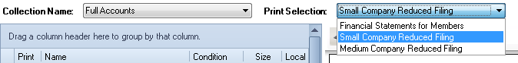

Previously in master pack 7.00 when generating the filing copy of the accounts, CCH Accounts Production had adopted a manual approach to “filleting” the accounts and required the user to physically remove the A4 pages that were not required to be filed on the public record.

This was done in order to ensure the page number references displayed in the filing copy matched the original references contained in the set of accounts produced for the members of the company.

Following feedback and further clarification from technical sources, we have now altered this approach.

In master pack 8.00 and above, when printing the reduced filing copy, pages and notes will automatically be suppressed from the printed output.

The following primary statements are suppressed:

* Directors’ Report
* Audit Report
* Profit & Loss account

The related Profit & Loss notes are also suppressed:

* Turnover
* Exceptional Items
* Operating Profit
* Auditors Remuneration
* Directors’ Remuneration
* Investment Income
* Interest Payable and Similar Charges
* Other Gains and Losses
* Taxation
* Discontinued Operations
* Dividends
* Impairments

The Contents page will supress the relevant rows, (instead of appending “[Not filed]” as was previously the behaviour in pack 7.00).

The Front Cover will continue to display “Pages for filing with Registrar”.

The Small Companies Filing Copy folder in the Statutory Database contains options to allow the user to include the Profit and Loss Account and Audit Report and/or Include the Directors’ Report if required;

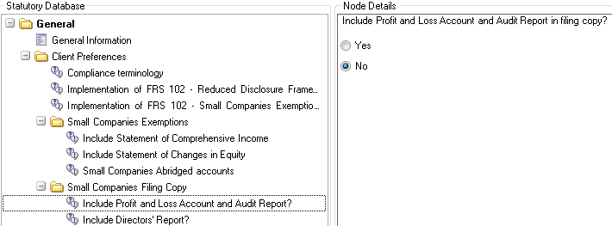

A new Audit Report Information note has been added to the FRS 102 master pack that will output in the Small Companies Filing copy if the Audit Report has been excluded. It will state whether the Auditors’ Report is unqualified or qualified and also contains details about the auditors.

#### 4) Small Company Reduced Filing/Small abridged accounts (Ireland)

A user preparing ROI accounts can claim the small size/abridgement exemption by selecting Medium Company Reduced Filing Copy from the drop down in the Financial Statements page. Selecting the option will:

* Exclude the Directors’ Report
* Exclude the Profit and Loss Account
* Produce the Special Auditors’ Report for small companies
* Trigger Balance Sheet statement regarding size/abridgement exemption
* Include new Directors’ Interests note (if text entered in Statutory database paragraph)
* Update Cover page to state Abridged and Contents page to exclude pages.

The overrides in the Statutory Database to allow the user to include the Directors’ Report and/or Profit and Loss account in the Filing copy.

# Appendix 5 - Companies Limited by Guarantee

### Introduction

A Company Limited by Guarantee (CLG) is a private company that does not have shareholders or share capital. It has members, called guarantors. The guarantors give an undertaking to contribute a nominal amount (typically very small) towards the winding up of the company in the event of a shortfall upon cessation of business. It cannot distribute its profits and these are generally reinvested back into the company. Because of this CLGs may apply for charitable status.

Common uses of guarantee companies include clubs, membership organisations, including student unions, sports associations, workers’ co-operatives, other social enterprises, non-governmental organisations (NGOs), charities and property management companies.

### Key Points

The key differences between a Company Limited by Guarantee and a normal Limited Company are as follows:

* Most companies that are guaranteed do not trade for profit: therefore you refer to the Income and Expenditure Account rather than Profit and Loss Account.
* Terms such as surplus/deficit are used rather than profit or loss.
* No share capital will appear on the Balance Sheet or within the notes.
* Since the company has no shareholders, the reconciliation of movements in shareholders’ funds is not required.
* A Members' liability note is disclosed.
* CLG's are both applicable to the UK and Republic of Ireland.
* The application does not support CLG’s for Charities.

### Statutory Database

To implement CLGs, within the statutory database access:

General>Client Preferences>Companies Limited by Guarantee (CLGs):

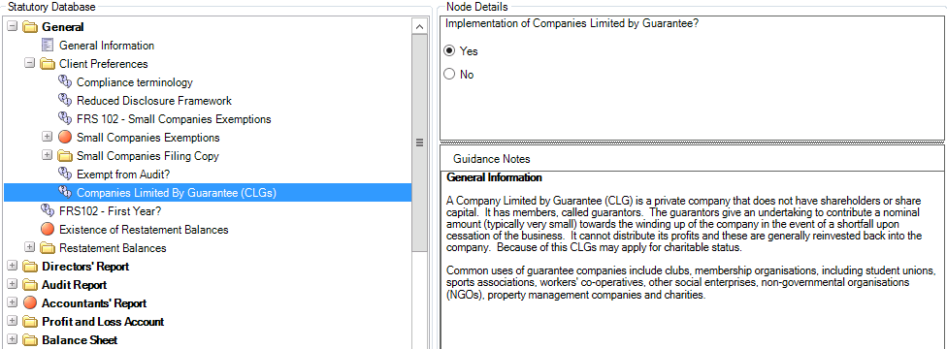

Within the statutory database we have added new nodes for CLGs that only appear once CLGs have been implemented. They are as follows:

* Accounting Policies
  + Income and Expenditure (#clg2)
  + Taxation (#clg3)
* Profit and Loss Account / SOCI Notes
  + Income/Service Charges
* Income (#clg4)
* Service Charges (#clg5)
* Free Format Text (#clg6)
  + Insurance (#clg7)
  + Fire Safety (#clg8)
  + Taxation (#clg9)
* Balance Sheet / SOFP Notes
  + Members' Liability (#clg10)
* Other Notes
  + Related Party Transactions (#clg13)
  + Common Areas (#clg11)
  + Planned Expenditure (#clg12)

Master paragraphs have been created where necessary and have either been set as default or are available from the picklist within the Statutory Database.

### Formats

Within the full collection the following new formats have been created:

* Insurance (CLG) - Note 101
* Fire Safety (CLG) - Note 102
* Members' Liability (CLG) - Note 103
* Common Areas (CLG) - Note 104
* Planned Expenditure (CLG) - Note 105

In relation to the following notes, new worksheets have been created within the existing note for CLGs:

* Turnover - Note05
* Taxation - Note18
* Related Party Transactions - Note74

Note: All pages and notes where necessary have been updated to look at #profit and #loss so that if CLG is selected, the wording changes to Surplus and Deficit, rather than Profit and Loss.

### Recommended Postings

Service Charges Due

When posting 'service charges due' it is recommended to use nominal code 6785. This will ensure the correct wording within the Debtors note.

Service Charges Paid In Arrears

When posting 'service charges paid in arrears/advanced' it is recommended to use nominal code 8030 or 9191. This will ensure the correct wording within the Creditors notes.

Sinking Fund

When posting balances to the 'Sinking Fund' it is recommended to use nominal codes 9745 to 9747. This will then flow through to 'Other Reserves'.

Note: Users will need to edit 'Other Reserves Headings' within the Statutory Database:

Balance Sheet/SOFP Notes>Own Shares and Other Reserves>Other Reserves Headings.

#### Conversion of existing CLG jobs in CCH Accounts Production (VAP)

Sites in Ireland may already have CLG jobs set up in VAP. These may be converted into CCH Accounts Production in the normal way, but after converting you must remember to go into the Statutory Database and re-select the CLG option, as described above.

# Appendix 6 - Compliance Terminology function

The Compliance Terminology function provides a set of variable terms used on formats and within paragraphs that can switch between "companies act" terms and their IFRS equivalents, depending on the preference of the user. (For example "Stocks" and "Inventories").

The set of terms can be seen within Maintenance > Accounts > Compliance Terminology:

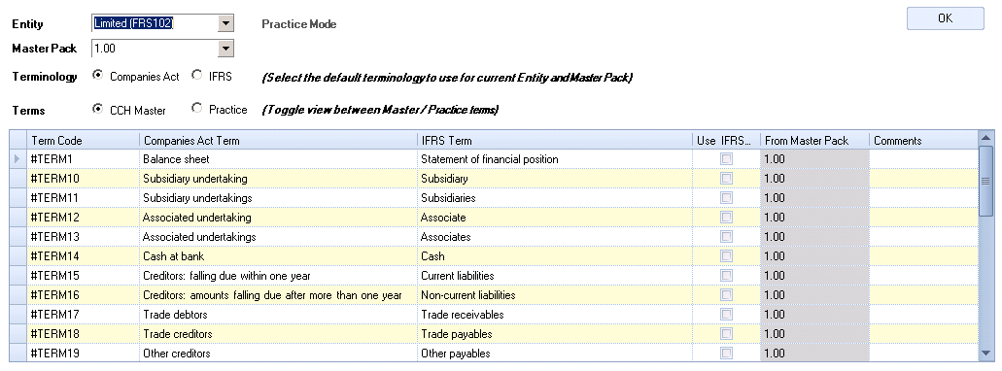

Not applicable to all entities

Some Entities within CCH Accounts Production do not offer the Terminology choice, so for those Entities the maintenance screen will display the following message:



Currently only Limited (IFRS), Limited (FRS 102) and Consolidated (FRS102) support the compliance terminology function.

Default selection for the Practice

From the Maintenance > Accounts > Compliance Terminology screen you may choose the default terminology that your firm will use when creating a new FRS 102 job. Simply make your choice by selecting the required radio button:



Any new accounting period created will default to use the same terminology as selected here, but individual accounting periods may subsequently be changed to use the other choice if required, by editing their Statutory Database.

Editing the Master Terms

If you wish to vary a given term, for example you would prefer to use "Cash" rather than "Cash at bank" for Term 14 when in Companies Act mode, then you can simply over-type the cell. (Note you will need to be in a draft master pack version before you can edit this however).

Creation of additional Terms

If you wish to create new Terms for use on your own customised formats, then you can do so as follows.

Firstly, move the radio button to the "Practice" terms option:



A blank grid will now be displayed, and you can enter additional terms as required.

The "Term Code" field will be automatically filled in as you type into the Companies Act Term column. The new terms you add are given a slightly different syntax: #CustomTerm0, and to reference these on a Format, you must use the command =AP("#CustomTerm0")

Note: The selection of terminology will only impact the accounts print preview. Other areas of the software will not be updated to reflect the terminology choice. For example the format names, statutory database node names and nominal code descriptions will not switch, as illustrated in the example below.

Example 1 - IFRS Mode selected:

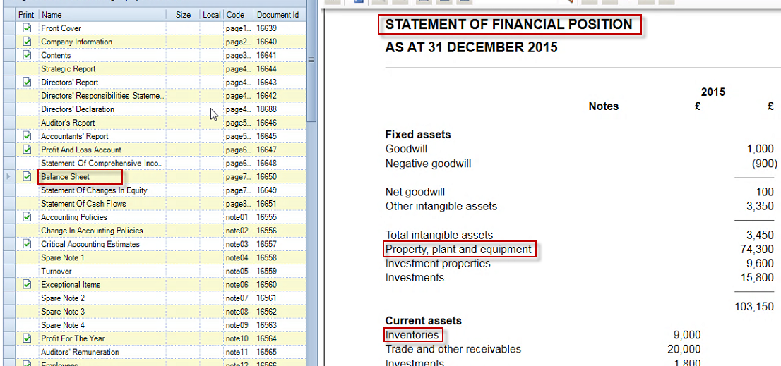

Example 2 - Switched to Companies Act Mode:

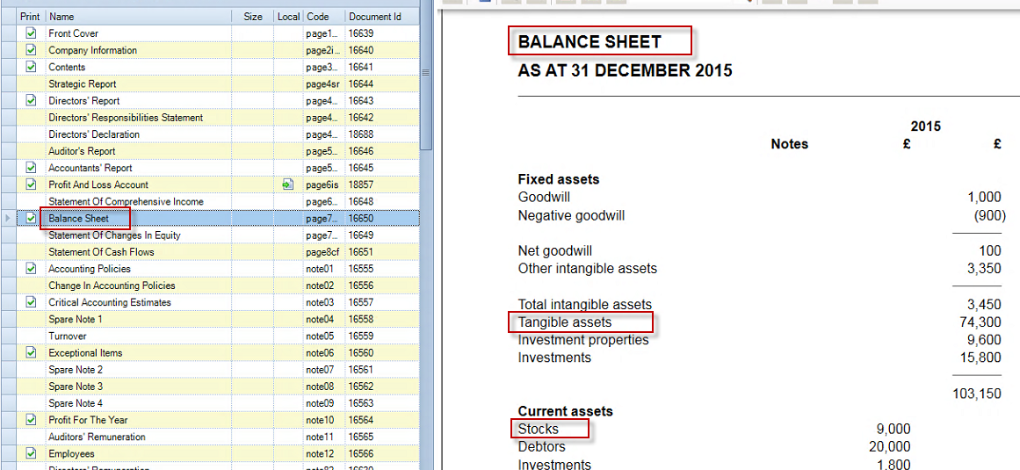

# Appendix 7 - Additional matters for Republic of Ireland

### **Directors' Responsibilities**

In the old Viztopia Accounts Production, the financial statements over disclosed somewhat and displayed the Directors' Responsibilities on both the Director's Responsibilities statement and the Balance Sheet.

In the new FRS102 master pack, for a non-audit job, this is only displayed on the Balance Sheet and the separate Directors' Responsibilities format is not printed.

(If you wish to still include the separate Directors' Responsibilities format, this can be done by right clicking the format in the Financial Statements screen and selecting "Include").

### Ireland small abridged accounts section 353 Companies Act 2014

In Master Pack 9.00 the option to produce small abridged accounts for filing under section 353 of the Companies Act 2014 has been added to the FRS 102 Limited entity.

A user preparing ROI accounts can claim the small size/abridgement exemption by selecting Small Company Reduced Filing from the drop down in the Financial Statements page;

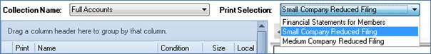

Selecting the Small Company Reduced Filing option will:

Exclude the Directors’ Report

Produce the Special Auditors’ Report for small companies

Exclude the Profit and Loss Account

Exclude the Statement of Comprehensive Income

Trigger Balance Sheet statement regarding size/abridgement exemption

Exclude the Statement of Changes in Equity

Include new Directors’ Interests note (if text entered in Statutory database paragraph)

Update Cover page to state Abridged and Contents page to exclude pages.

Exclude certain notes from printing.

In MP 9.00 a few of the notes to the accounts in the abridged collection have not been adapted from the full FRS 102 version and may require the following edits. These note are scheduled to be updated in MP 10.00.

Debtors note: The note will output in full in the abridged collection in MP 9.00. If there are no debtors greater than one year, a user can choose to exclude the note from the financial statement collection by right clicking on the format and choosing exclude. If there are debtors greater than one year a user can either allow the note to output, or they can suppress the note in the financial statement collection and in statutory database under Balance sheet/SOFP notes, under debtors there is an option ‘Materiality of Debtors > 1 year’ (statutory database reference #bn9991345). When a user selects yes to this option the debtors greater than one year will output in the balance sheet and therefore there is no need for the note.

Creditors due within one year note: This note outputs by default and the user can choose to exclude this note from the financial statement collection by right clicking on the format and choosing exclude.

Creditors due after one year and borrowings note: In MP9.00 the information regarding amounts due after more than 5 years to repaid in instalments and amounts due after more than 5 years not repaid in instalments is input in the statutory database under the creditors note and output in the creditors note. The text paragraphs detailing the terms and the paragraph addressing secured debt are under the borrowings note in the statutory database and output in the borrowings note. Both these notes will output in MP 9.00 if amounts are posted to the related nominals. In MP 10.00 these disclosures will be combined in one creditors note for the small abridged accounts.

Deferred taxation note: This note is output in MP 9.00 however the movement is not required and the note will be excluded in MP 10.00. The user can choose to exclude this note from the financial statement collection by right clicking on the format and choosing exclude.

Financial instruments note: This is the full FRS 102 note and is scheduled to be reviewed in MP 10.00.